**CS553 CLOUD COMPUTING: FALL 2022**

**HOMEWORK 1**

**Name: DEEKSHA PRABHAKAR**

**CWID: A20478791**

**A1.**

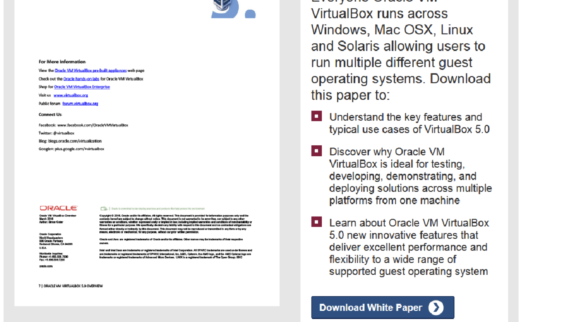

B. Since I am using mac m1, I have used UTM as suggested by Lan Nguyen.

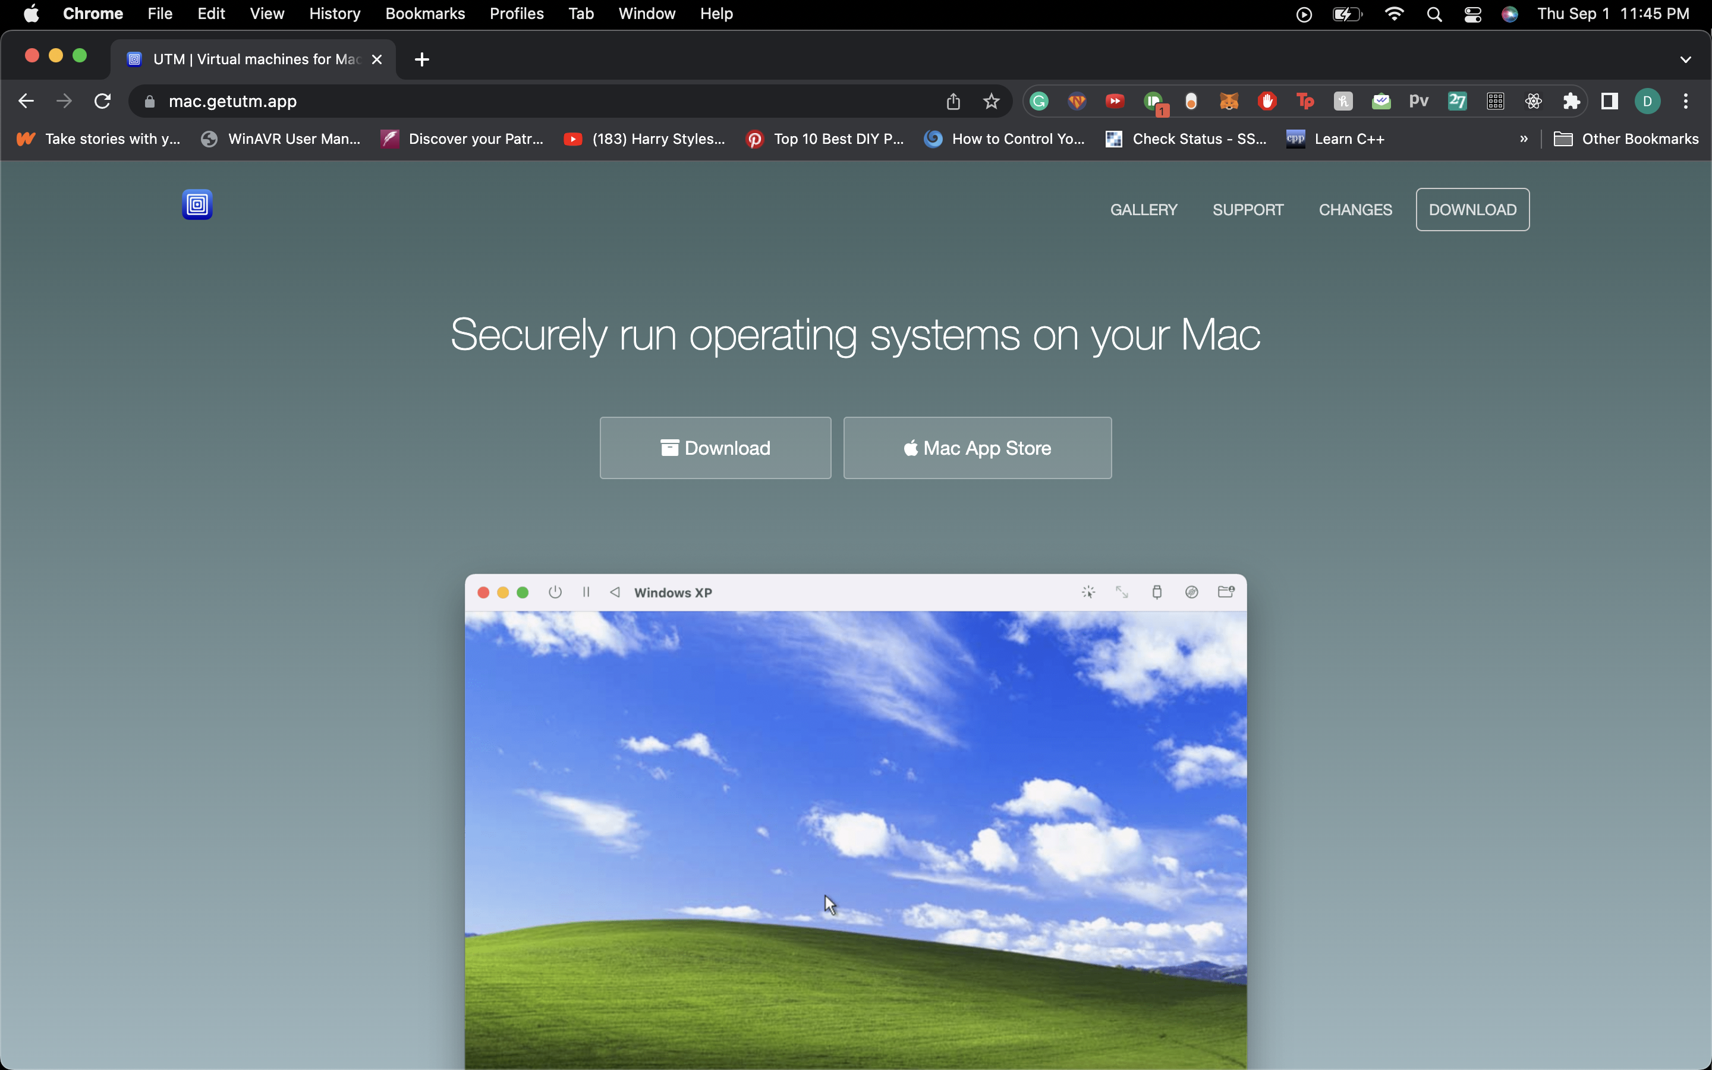

C.

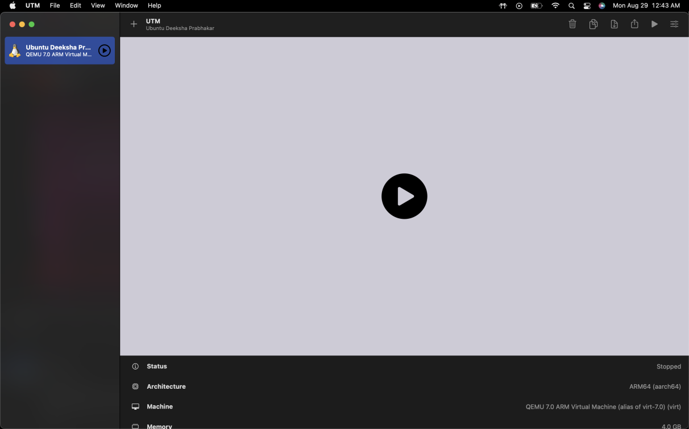

D.

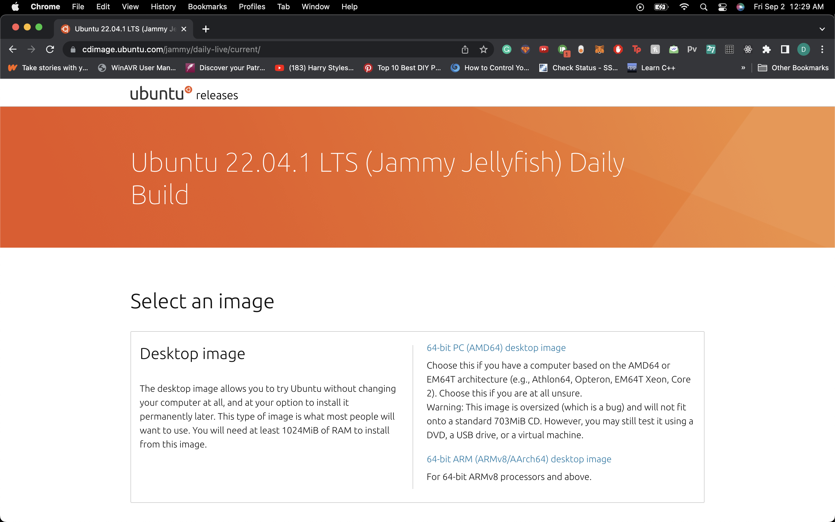

E.

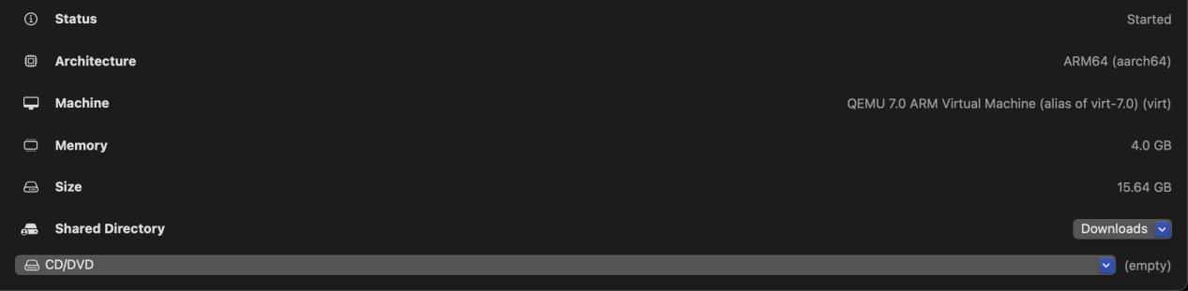

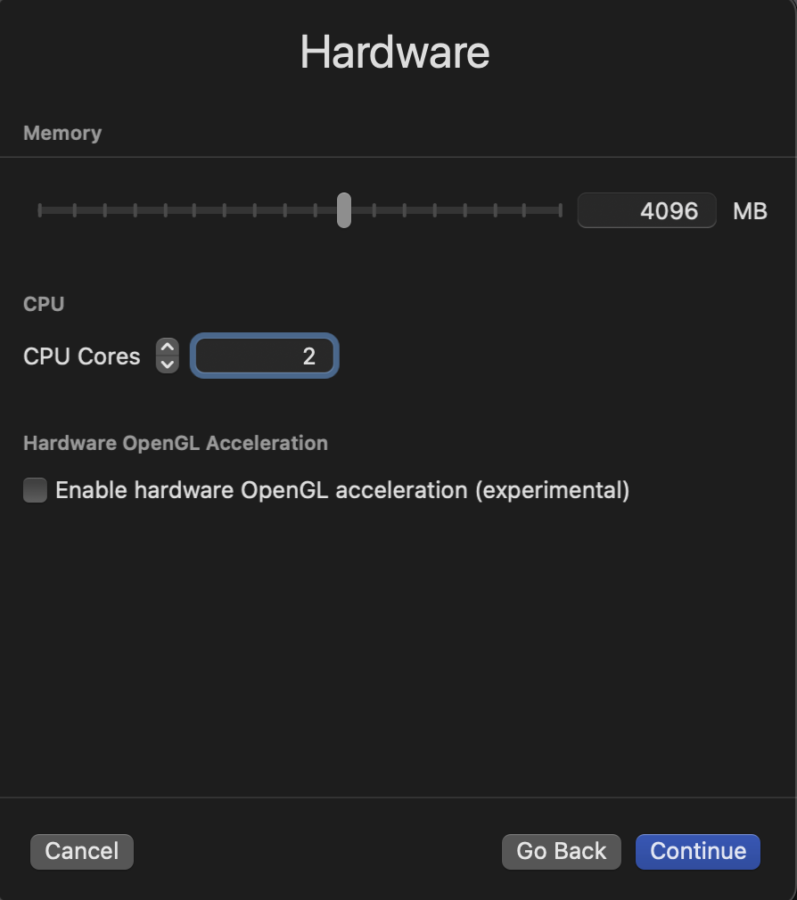

F.

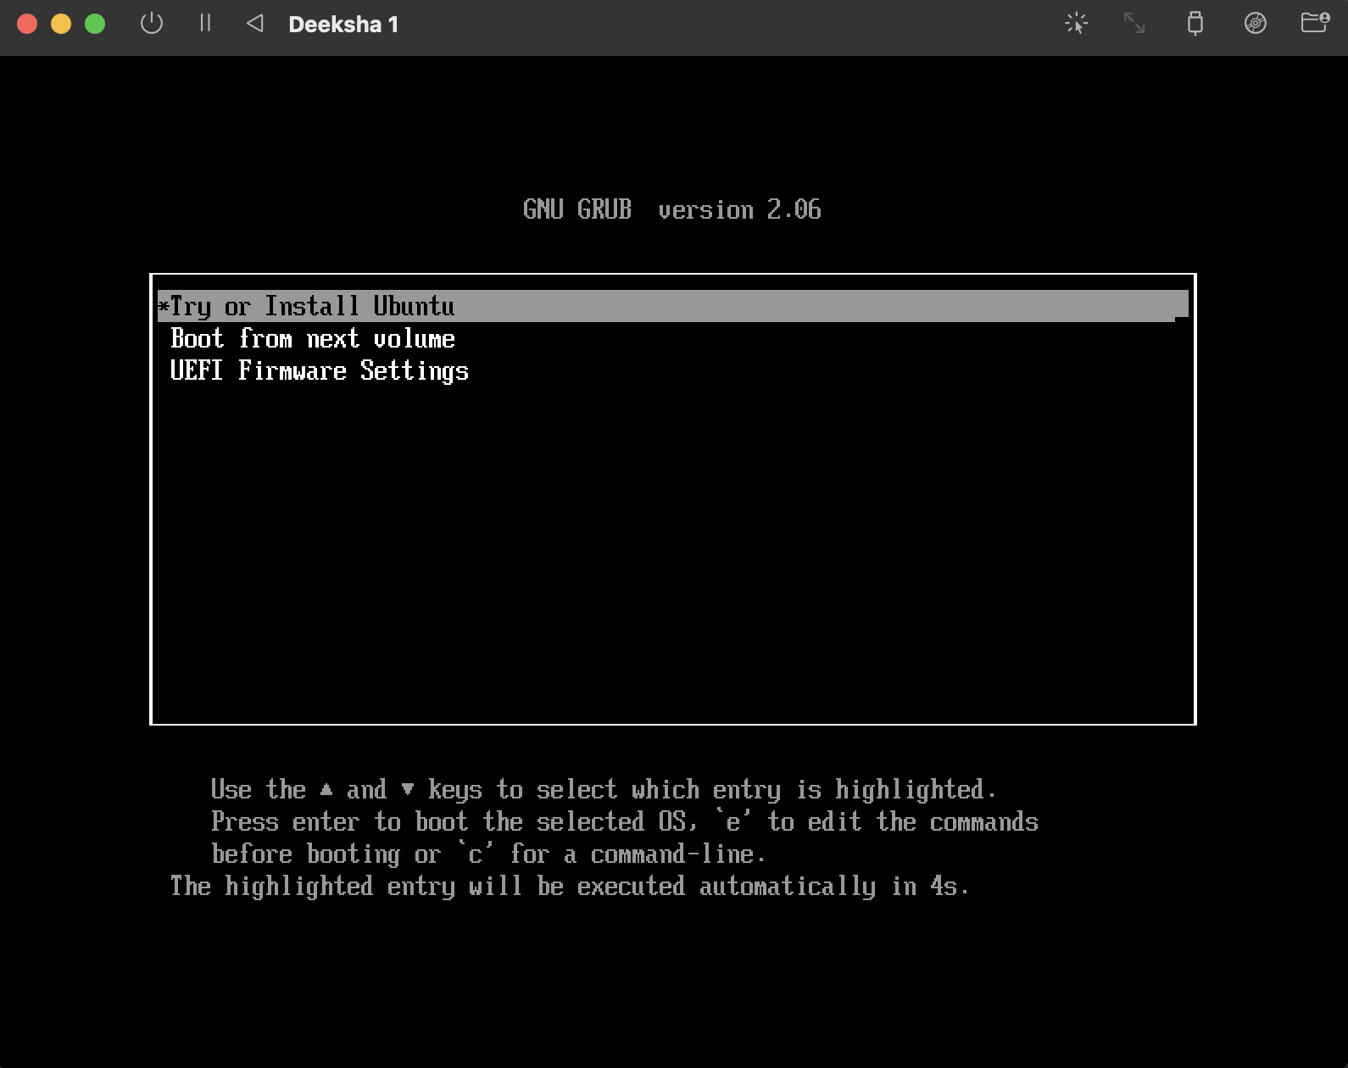

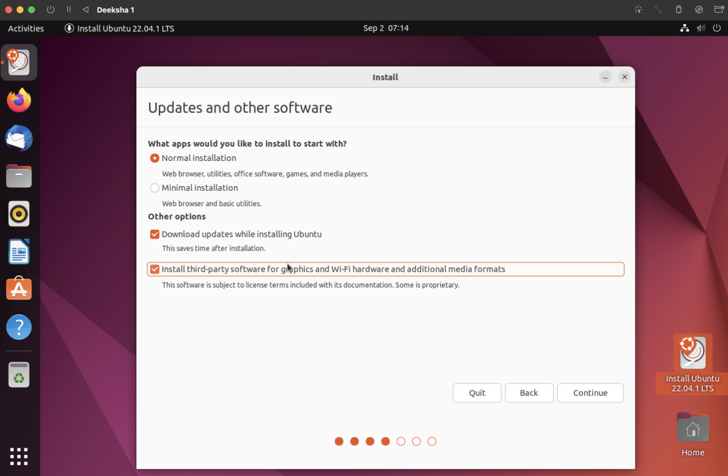

G.

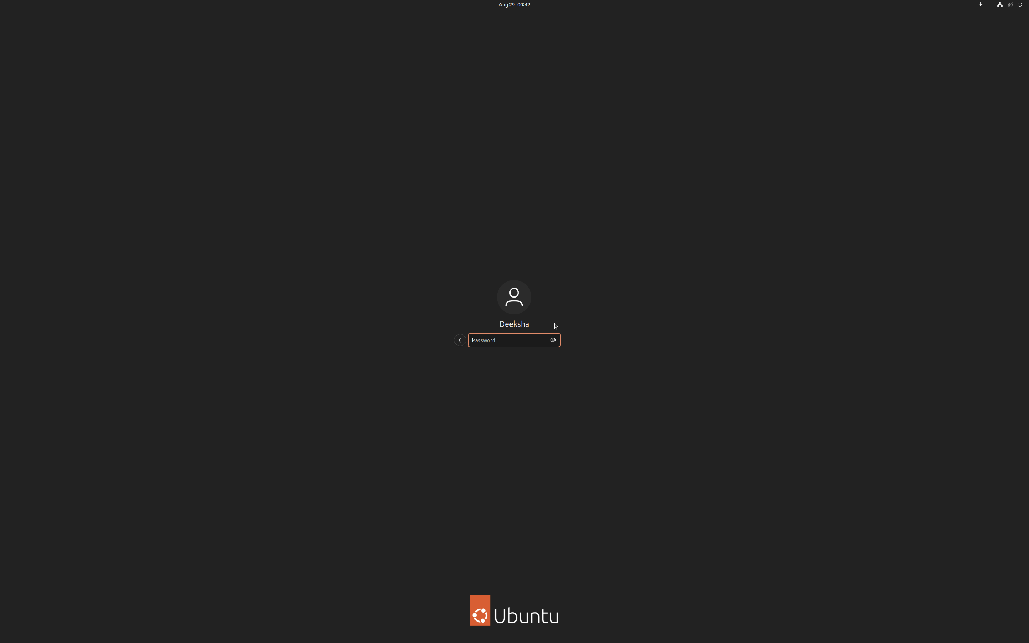

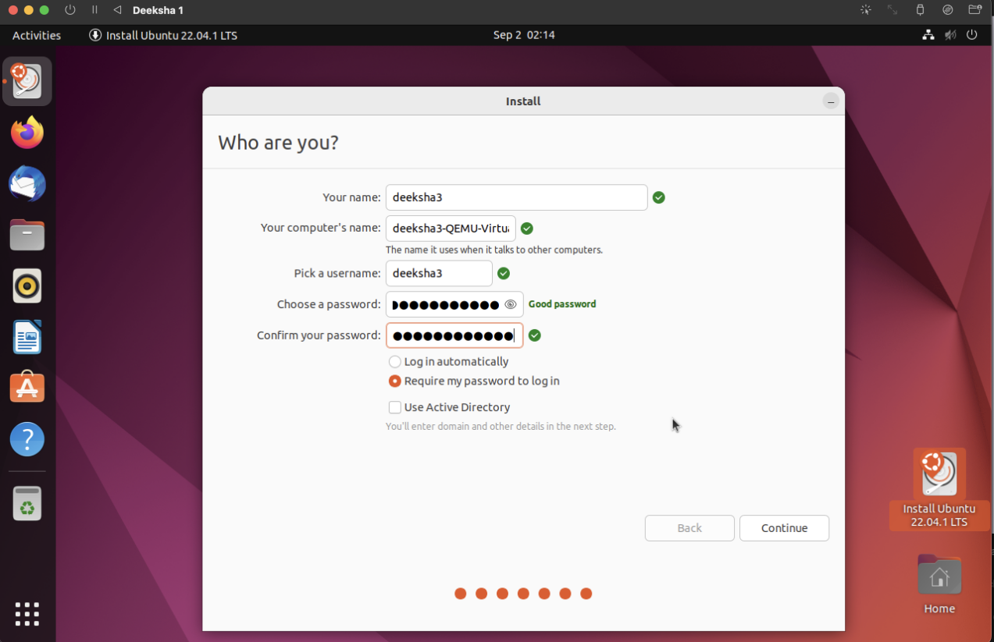

H.

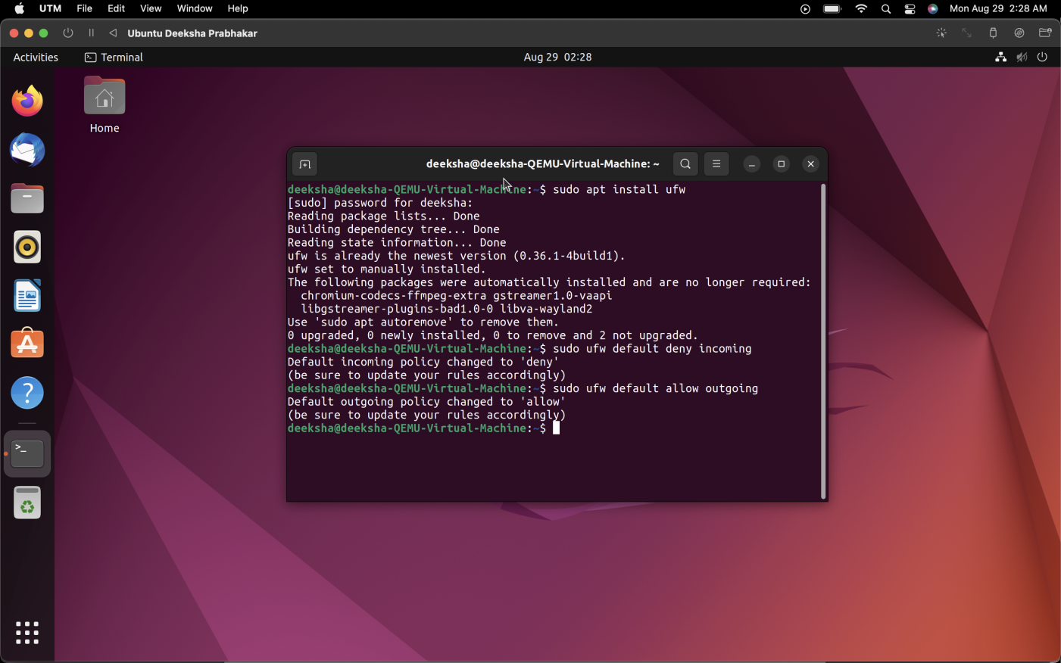

I.

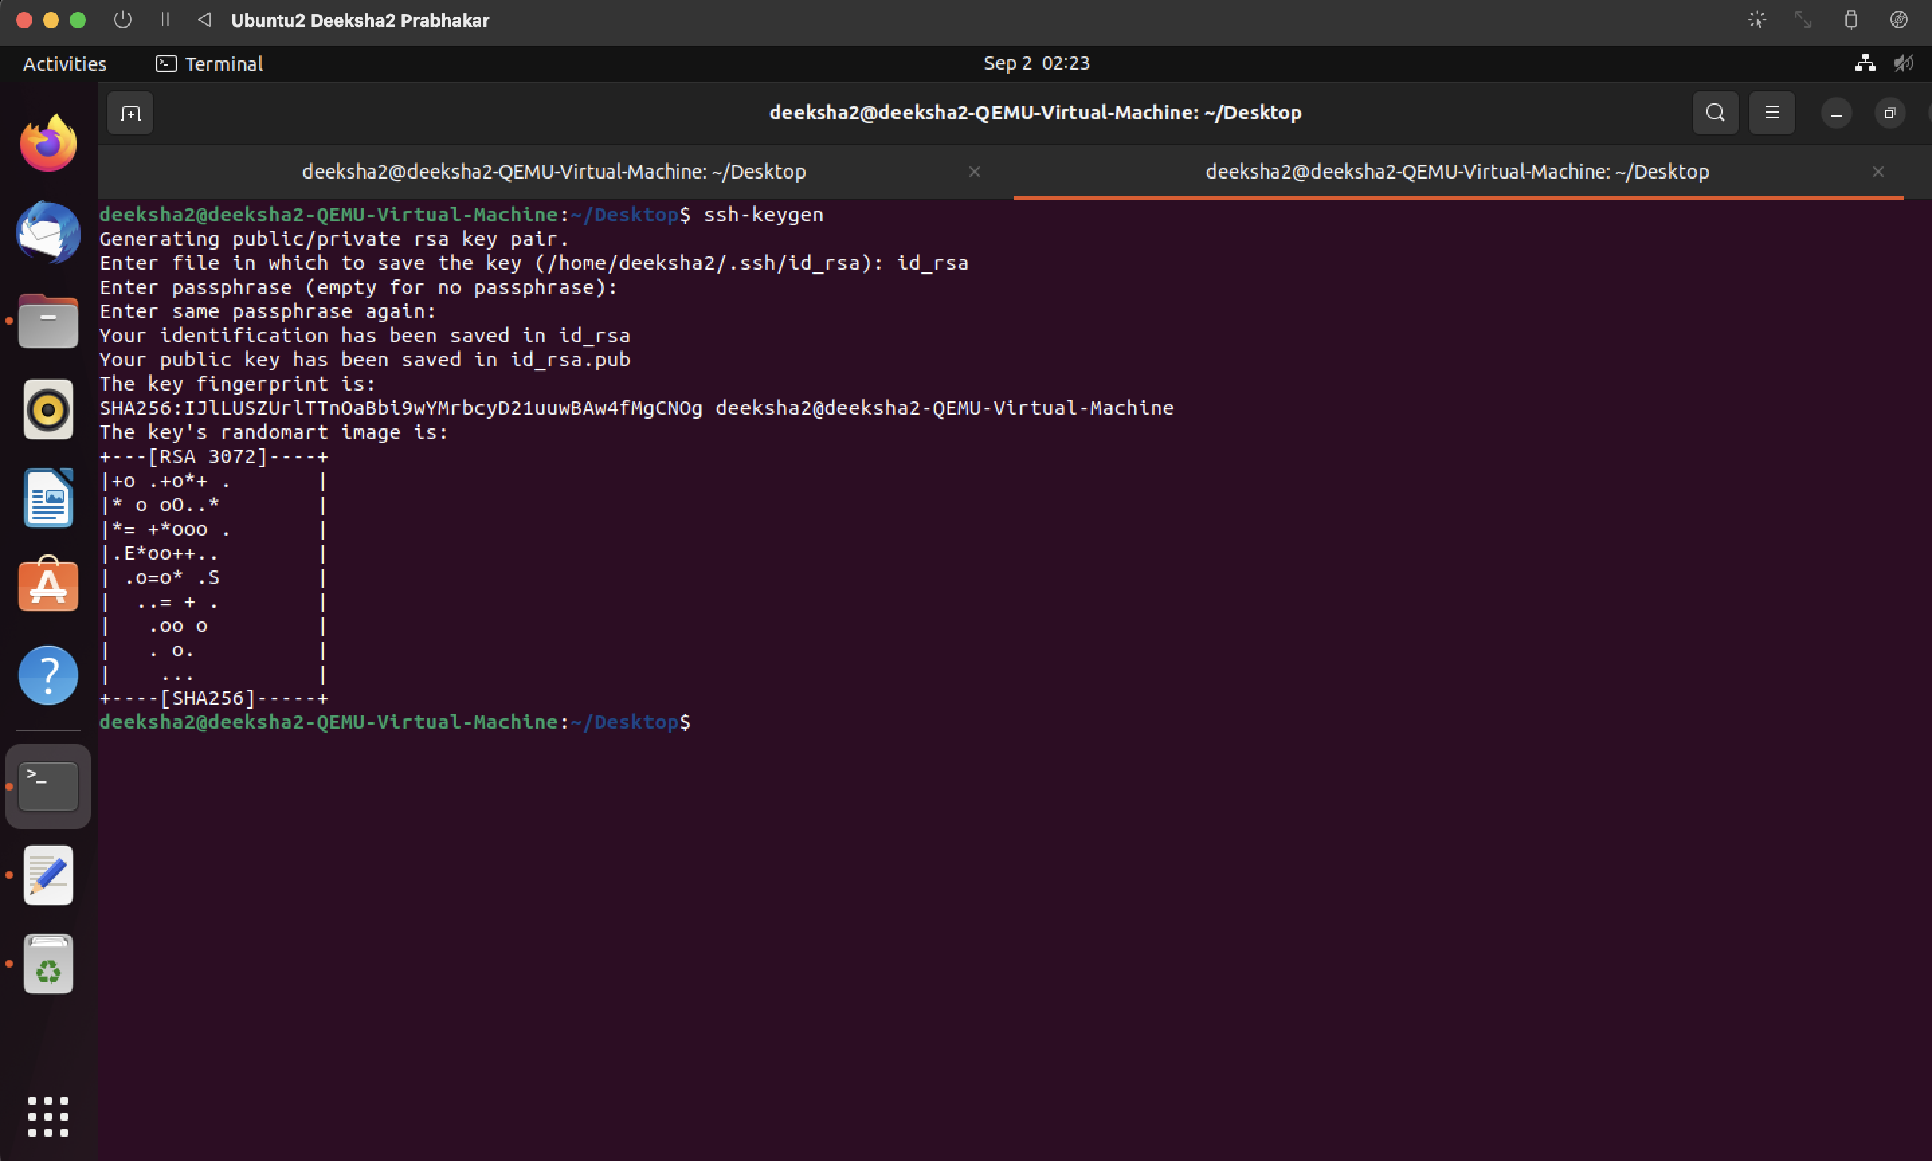 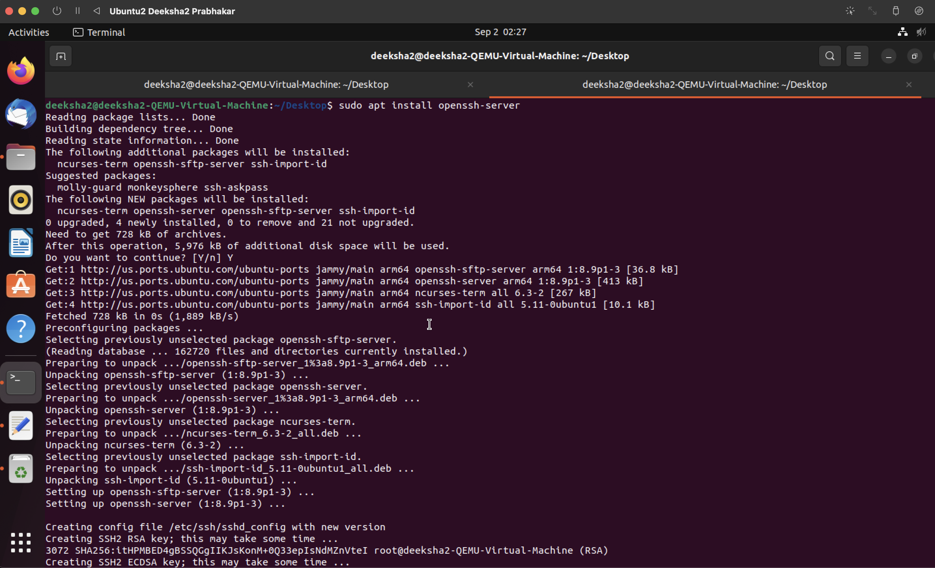

J.

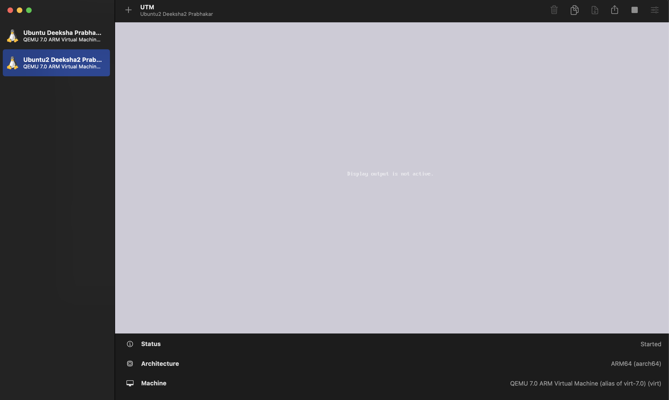

K.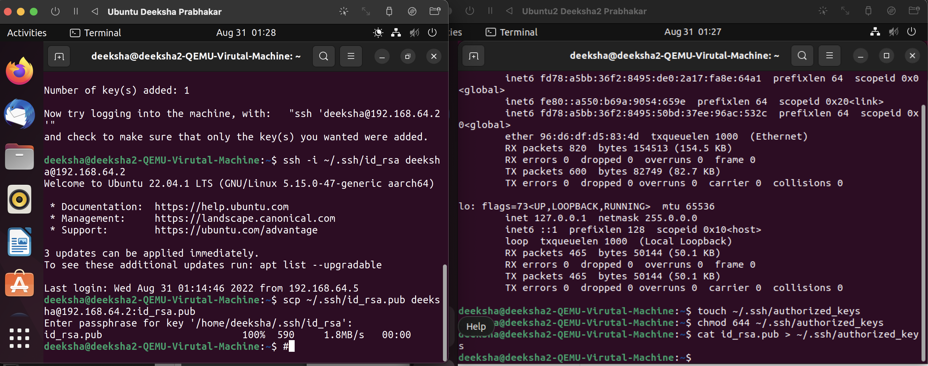

L.

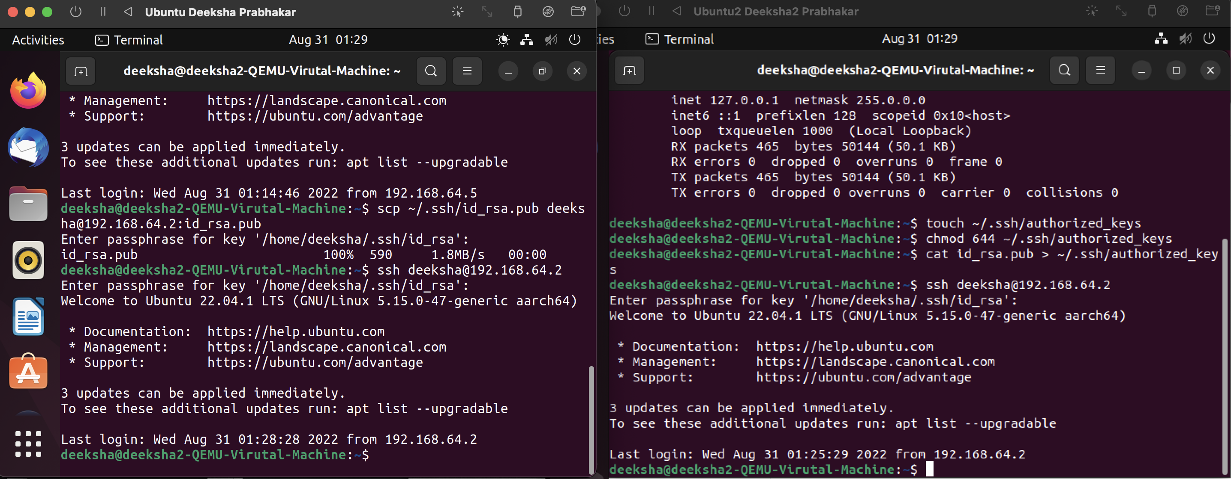

**A2.**

1. ssh- It is used to access local Bash scripts from a local or remote server.



1. ssh-keygen- This is used to create keys to connect and authenticate between the client and server.



1. scp- It is used to copy files between servers in a secure way.

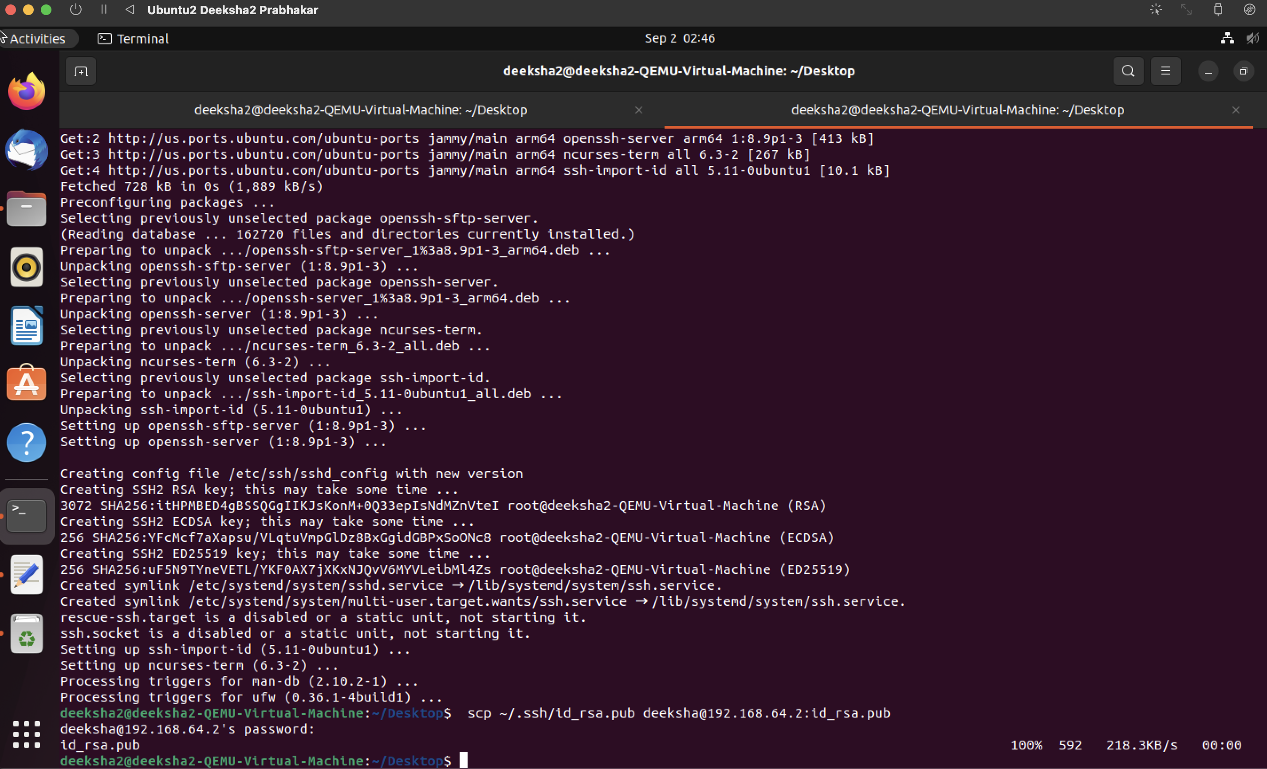

1. history- it is used to view the commands that were run previously i.e command history.

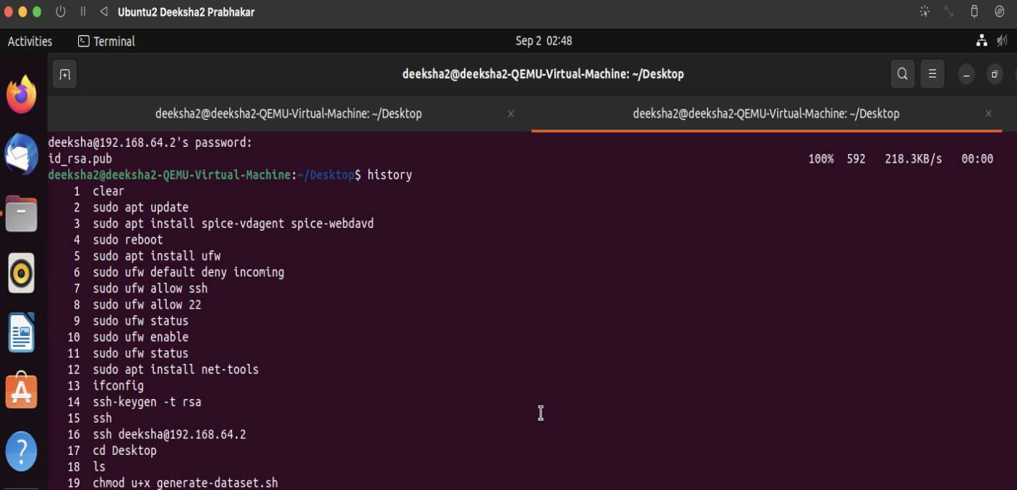

1. sudo- it allows users to run programs with the security allowances of super user.

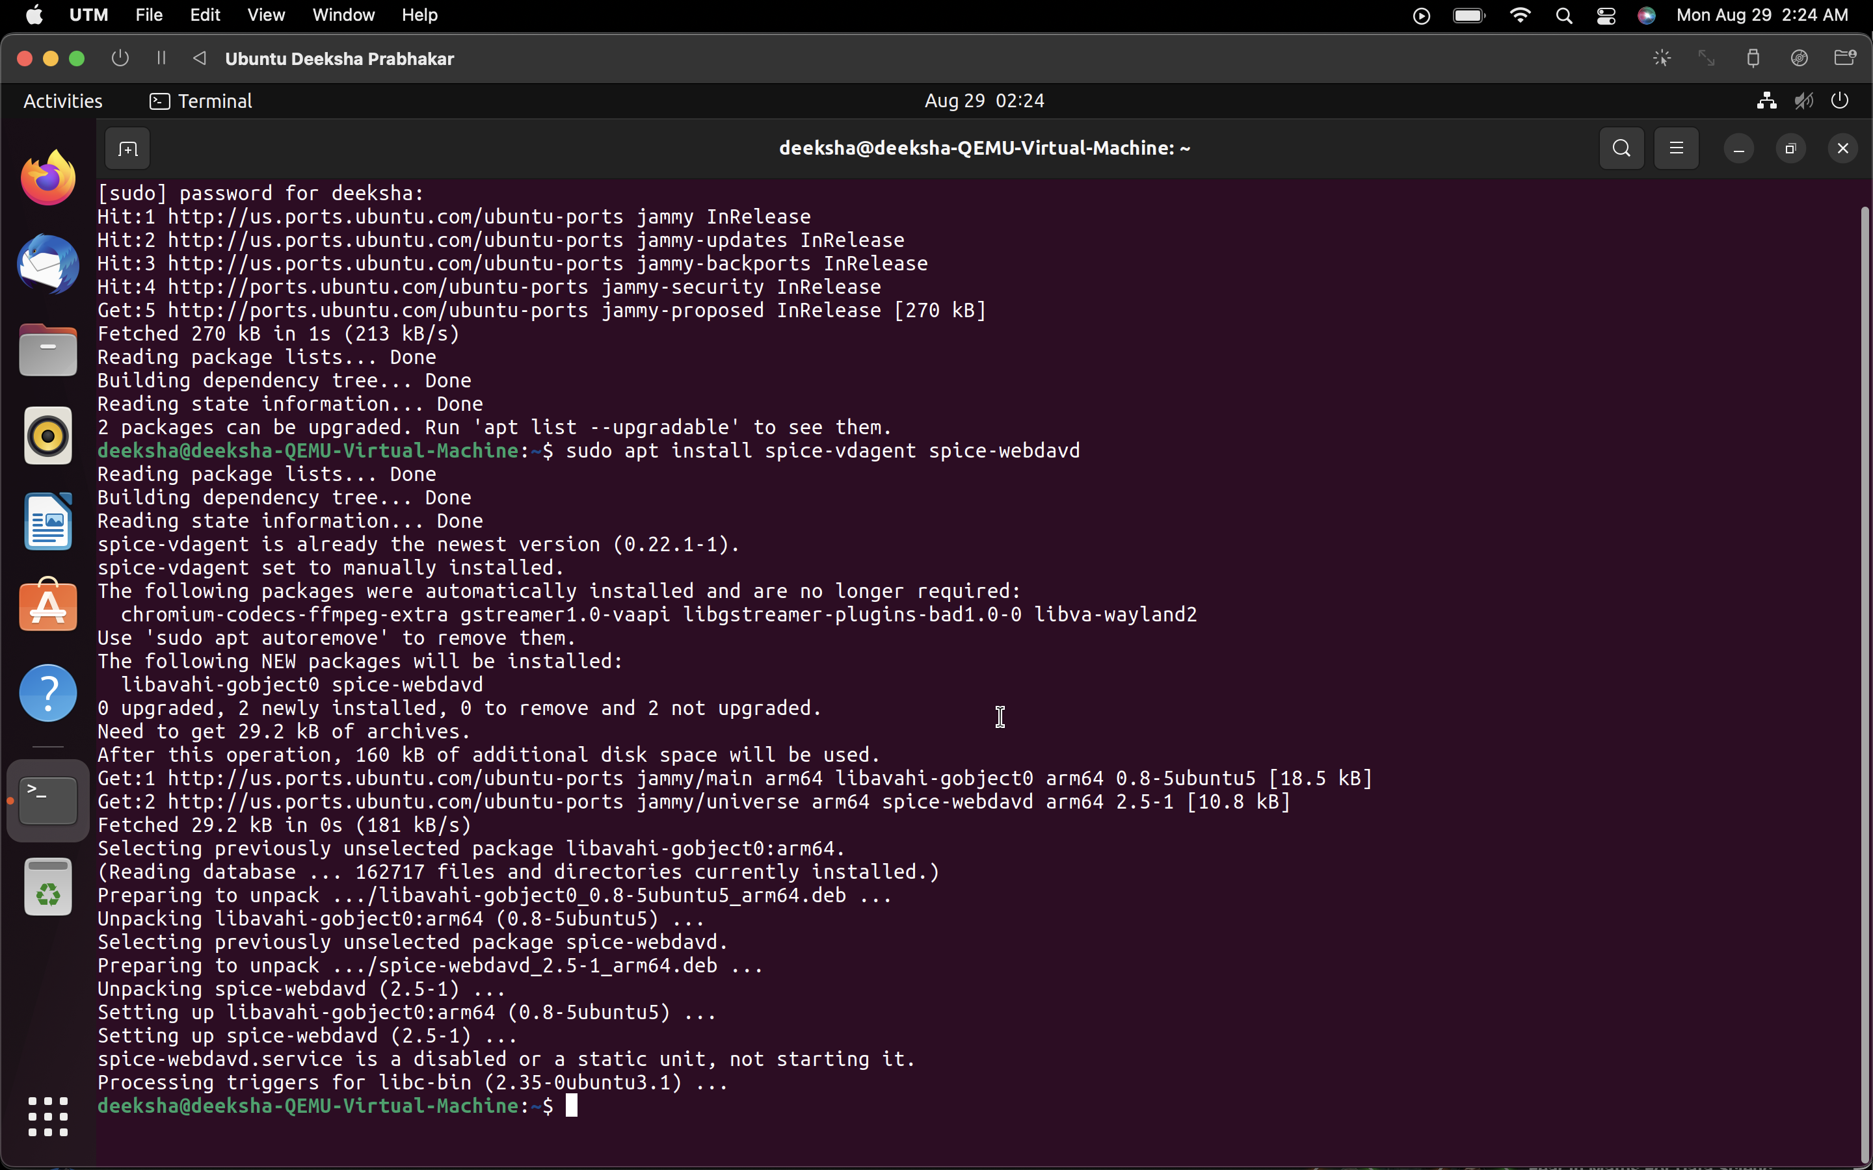

1. ip- it tells us about the ip addresses of the user.

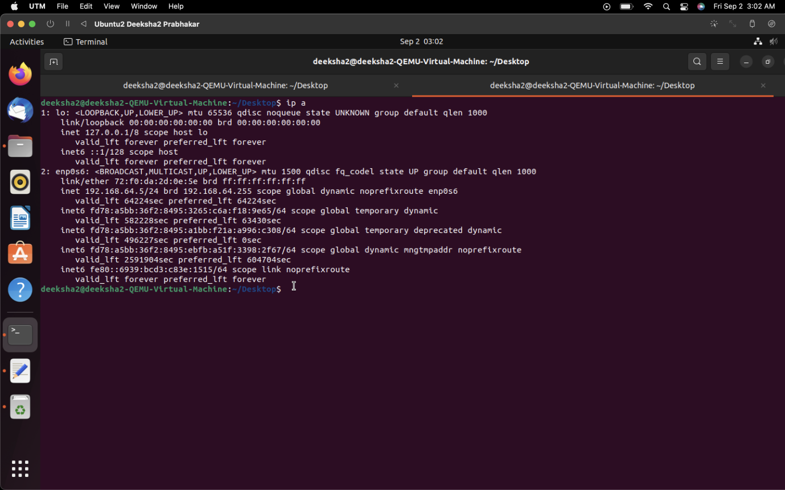

1. dd- it reads the input, processes it and then writes it into an input block.

Here, I have used dd to swap the bytes of input

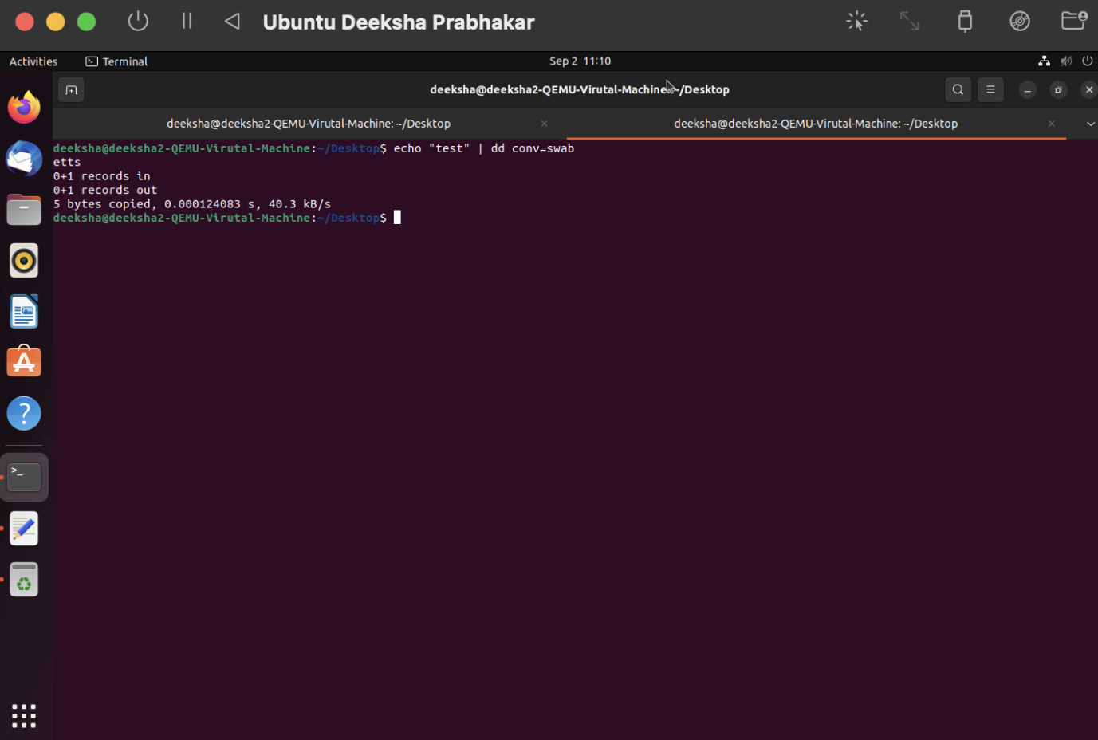

1. fdisk- It is used to create and manipulate disk partition and get disk partition information.

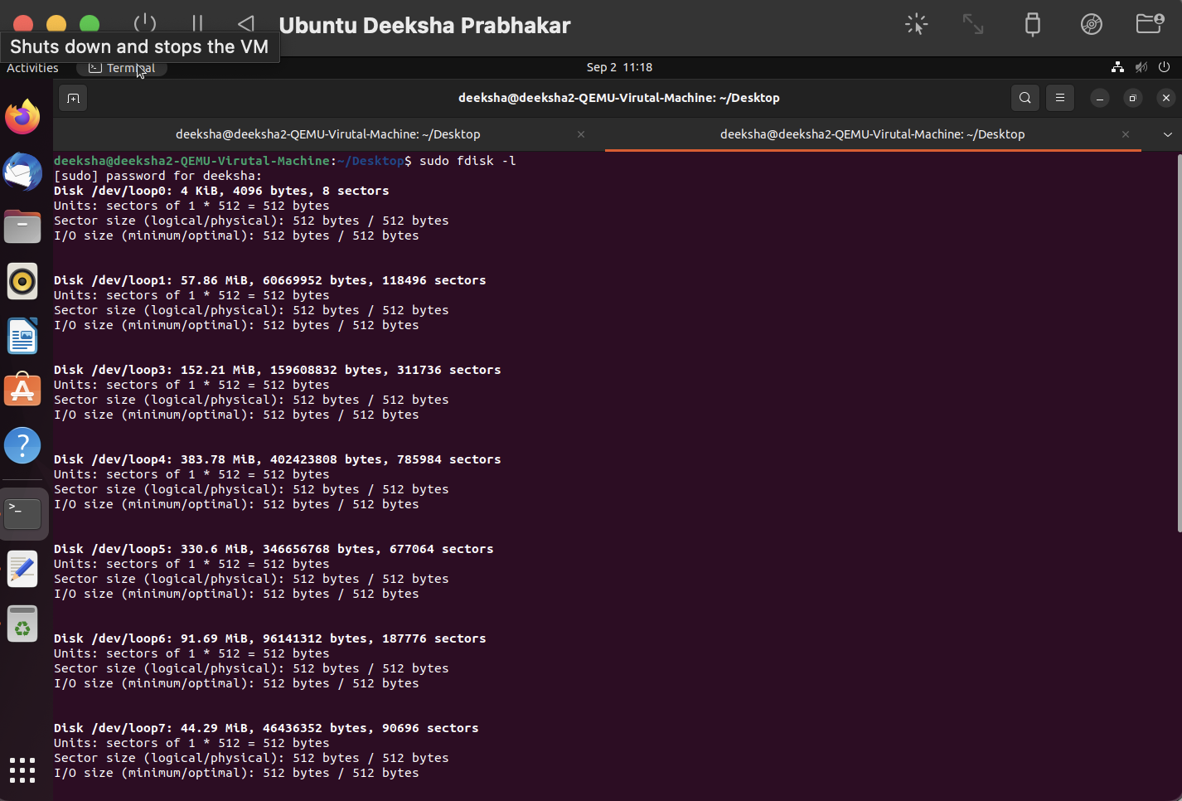

1. apt- It is used to install, update or manage packages.



1. vi- It is for using a command line text editor- it will create a tetx file and save it to the specified location.

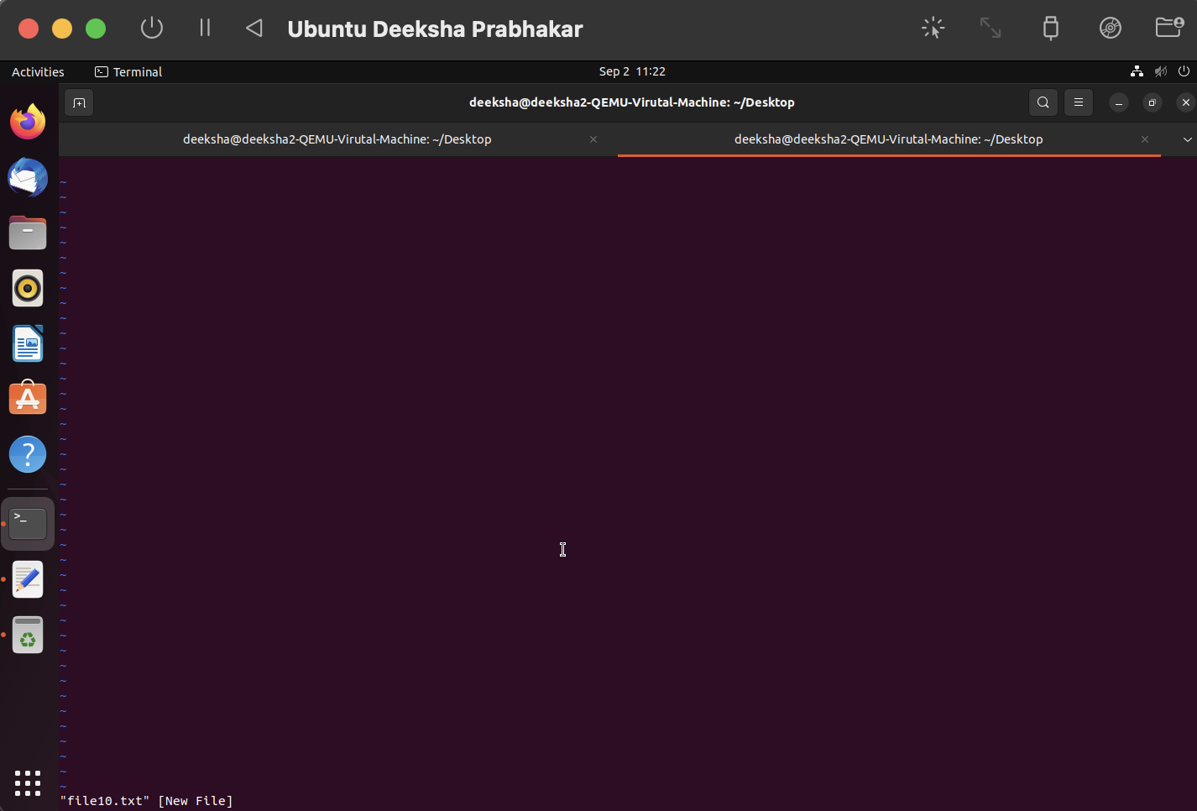

1. time- prints the time taken to execute a bash command or script.

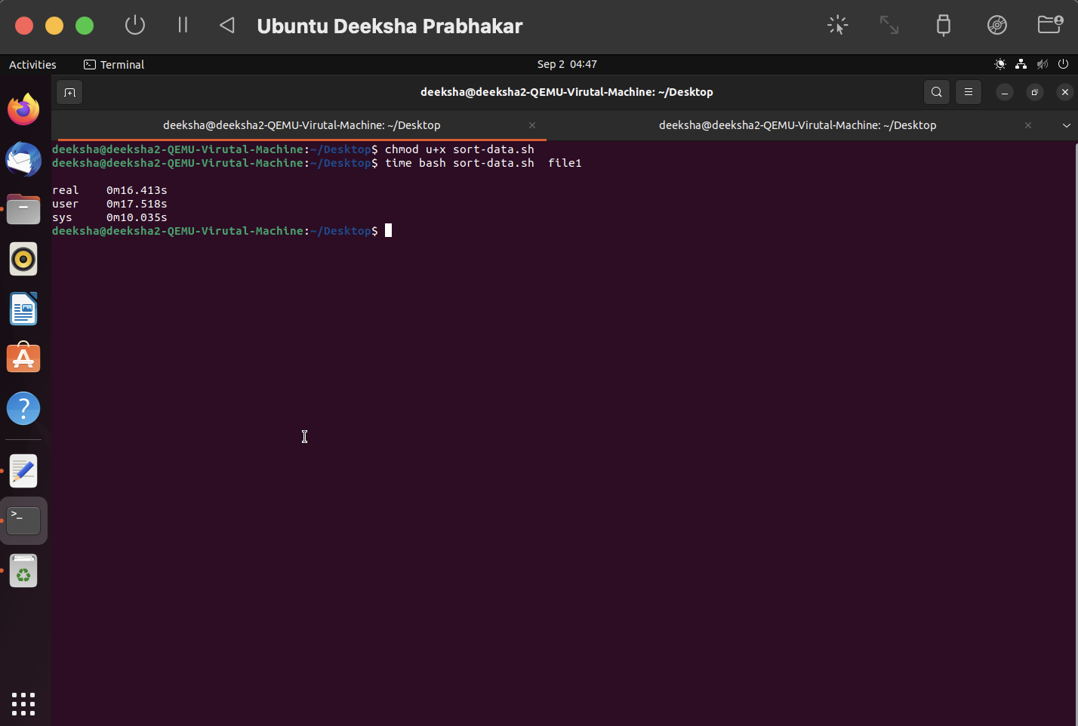

1. tar- It is used to create a tape archive, i.e it will create a tar archive file for the given directory.

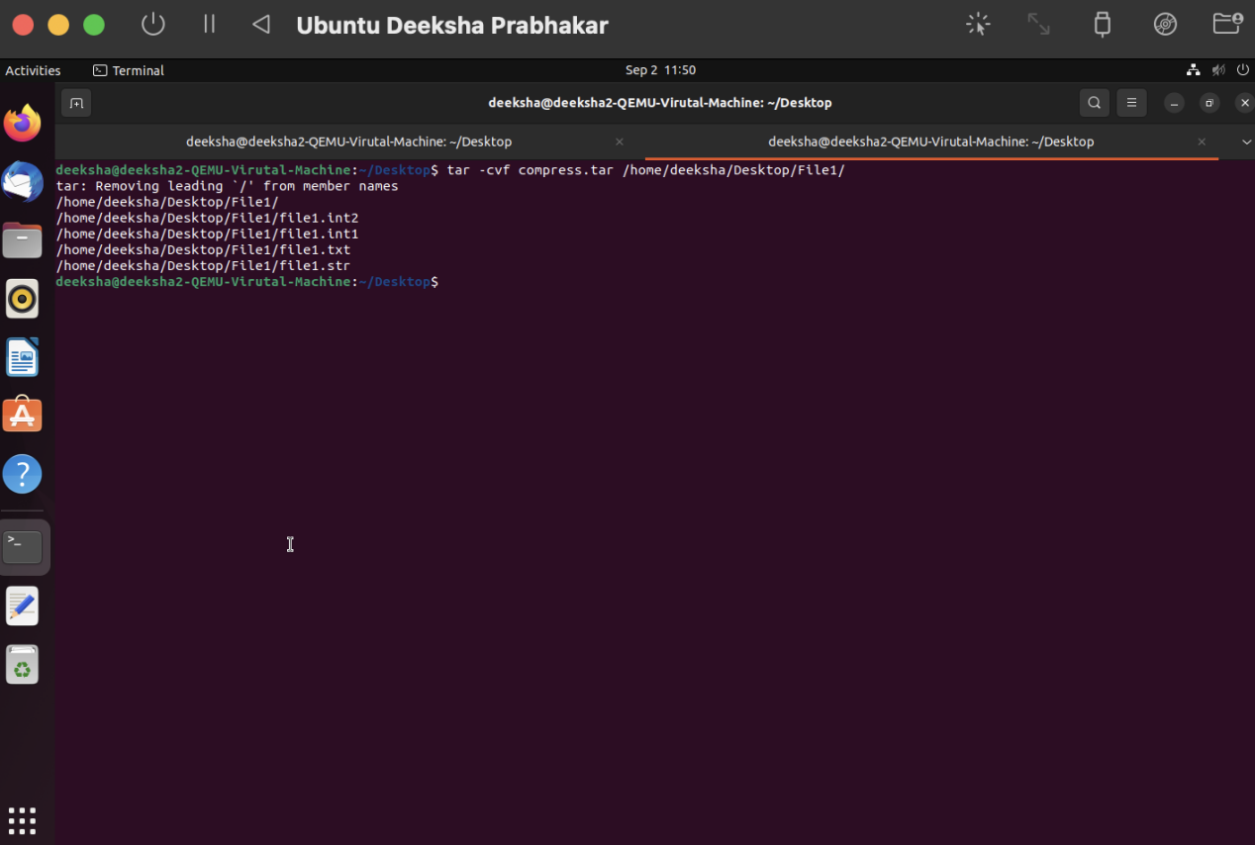

1. cat- stands for concatenate, it is used to create single or multiple files, view them, concatenate them etc.

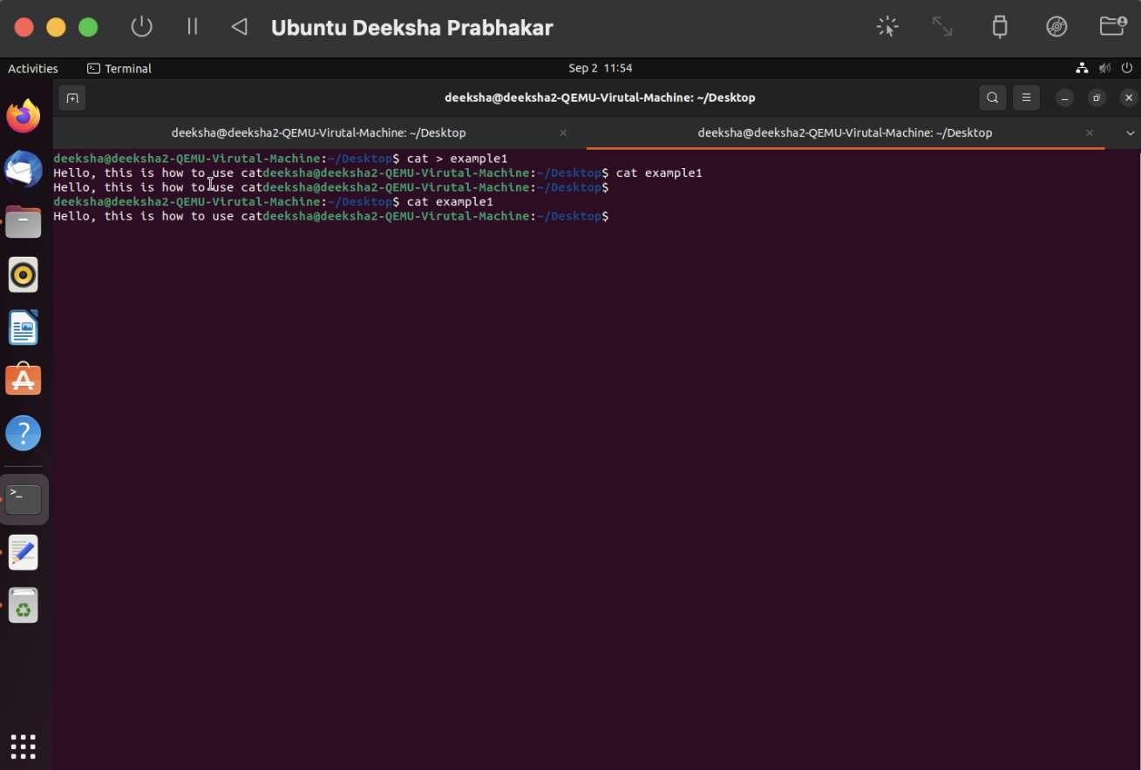

1. watch- It is used to run a program repeatedly and give the output at a certain time as specified by the user.

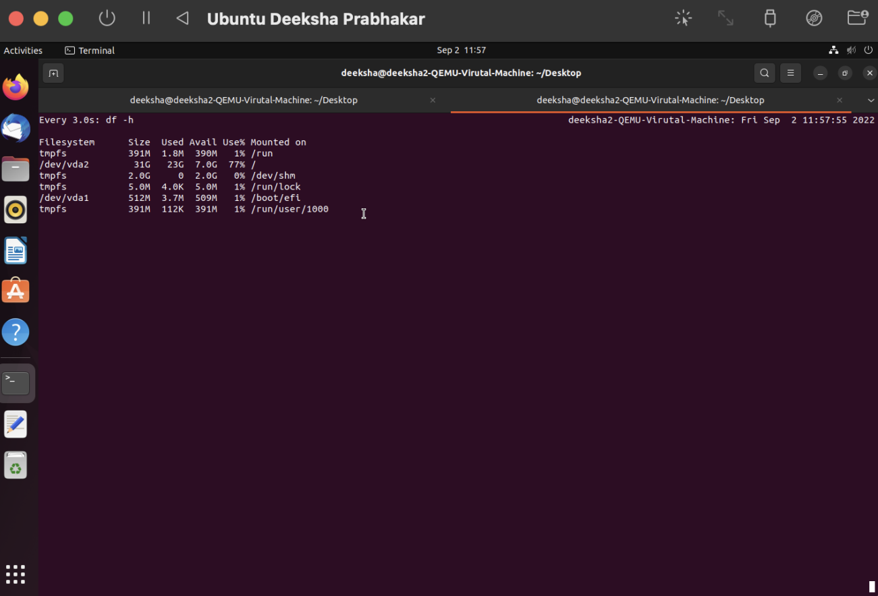

1. ps- shows information abut the running processes.

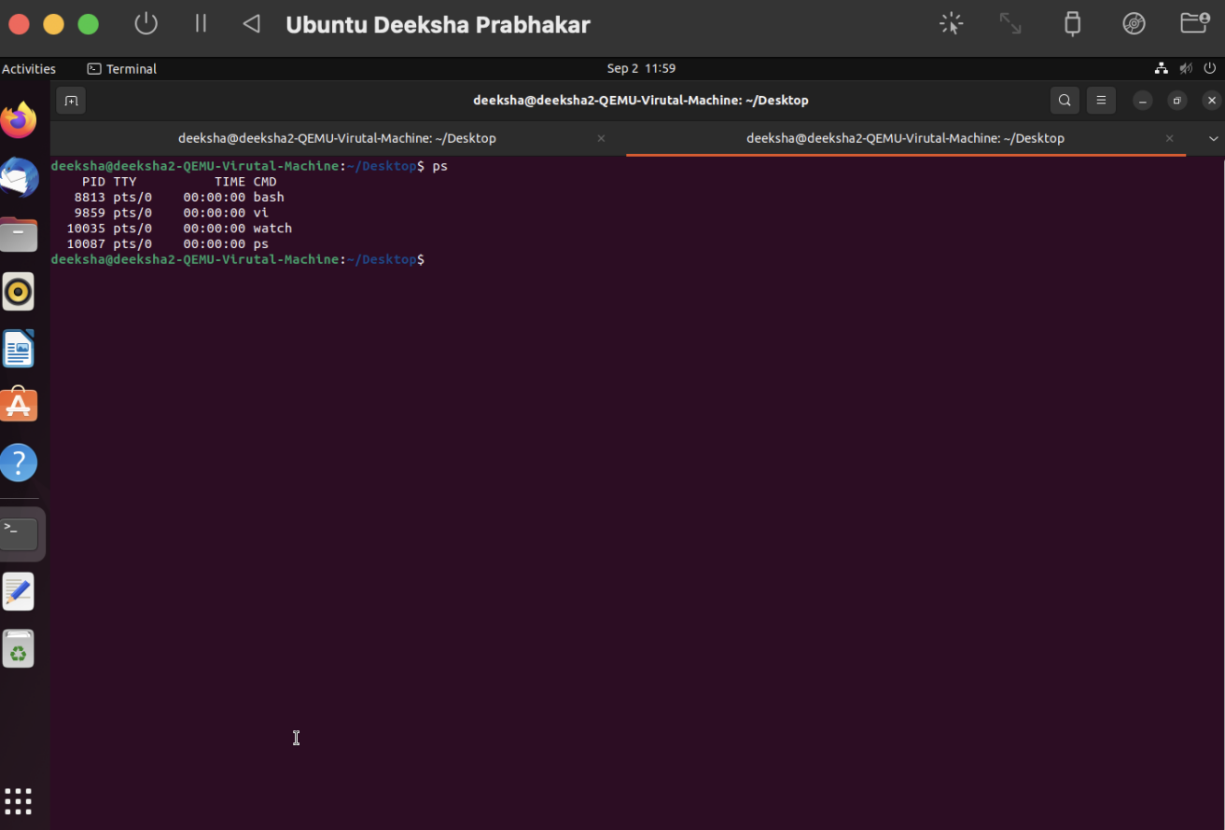

1. top- It is like a task manager that shows running processor operation, kernel managed tasks etc.

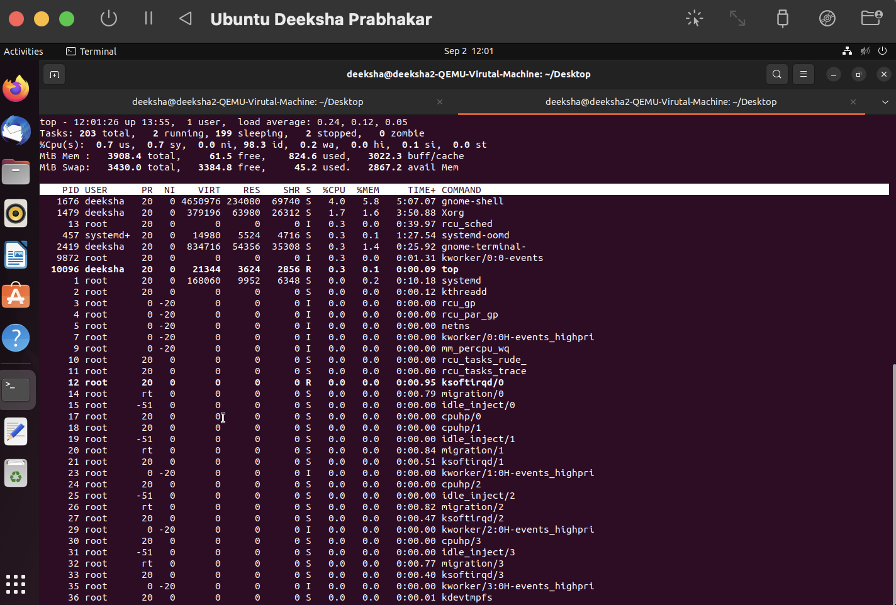

1. htop- shows processes running on the system and various operations like kill for those processes.

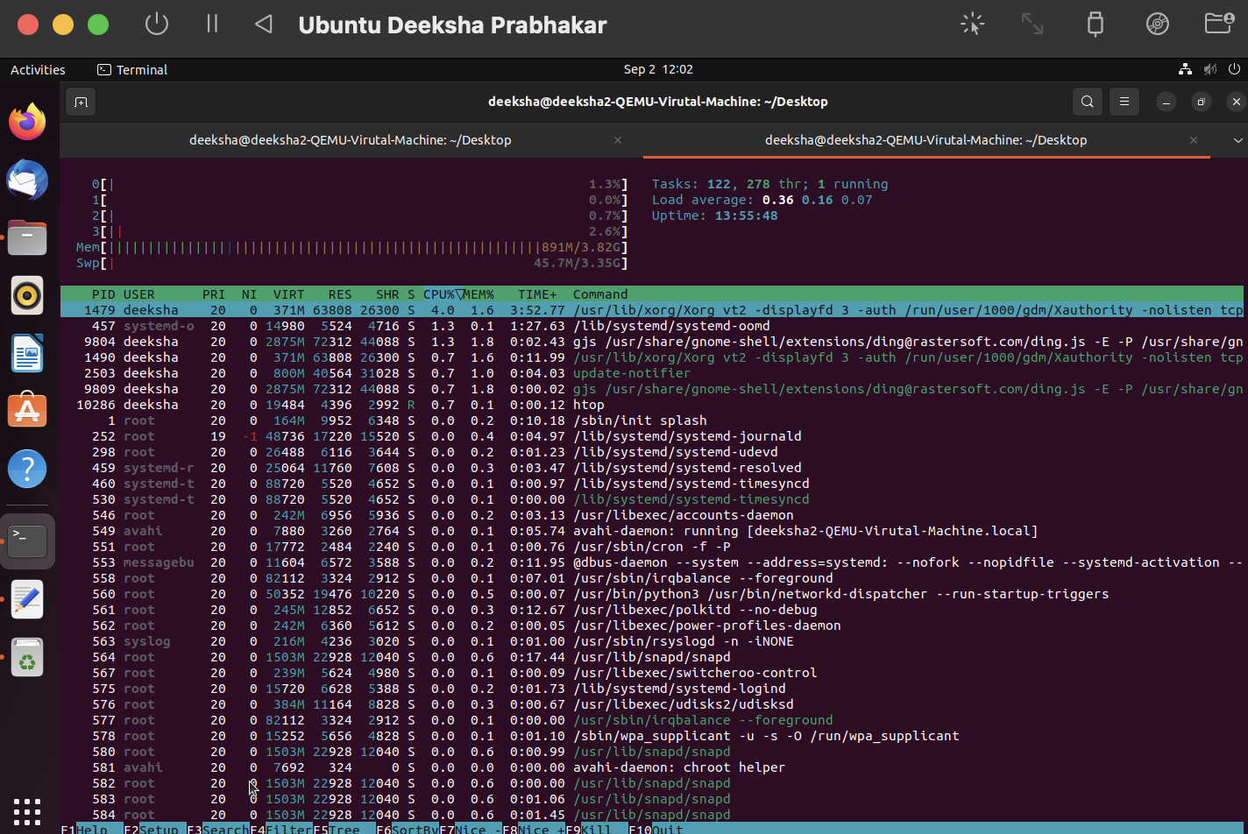

1. gcc- It is used to compile C and C++ language programs.

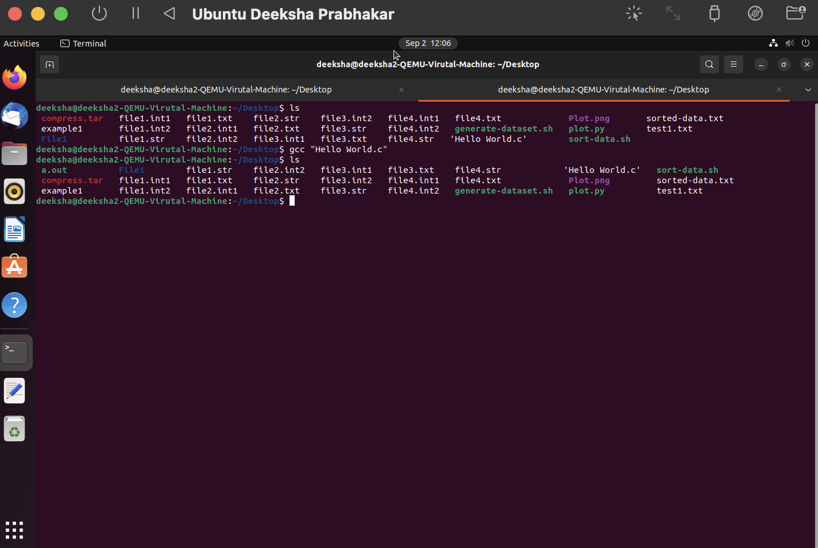

1. tail- it is used to run/ display the last few lines of a file.

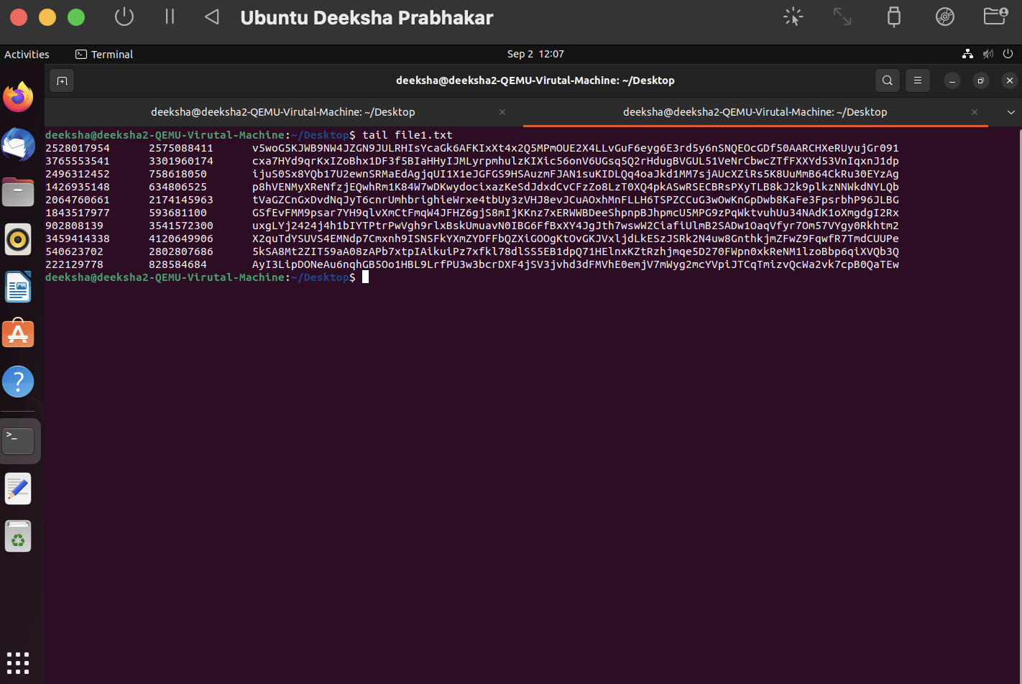

1. grep- search a file for a particular character or group of characters and return the parts that contain it.

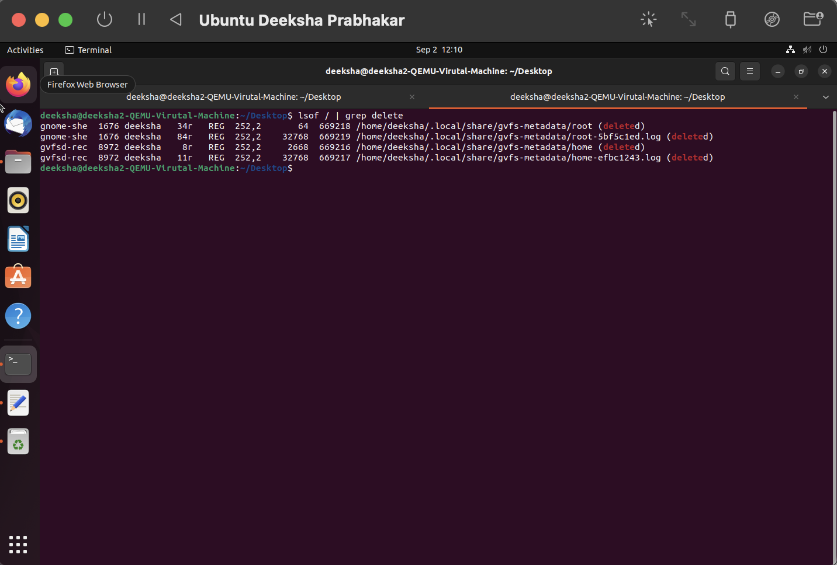

1. kill- it is used to kill the processes by id or name.

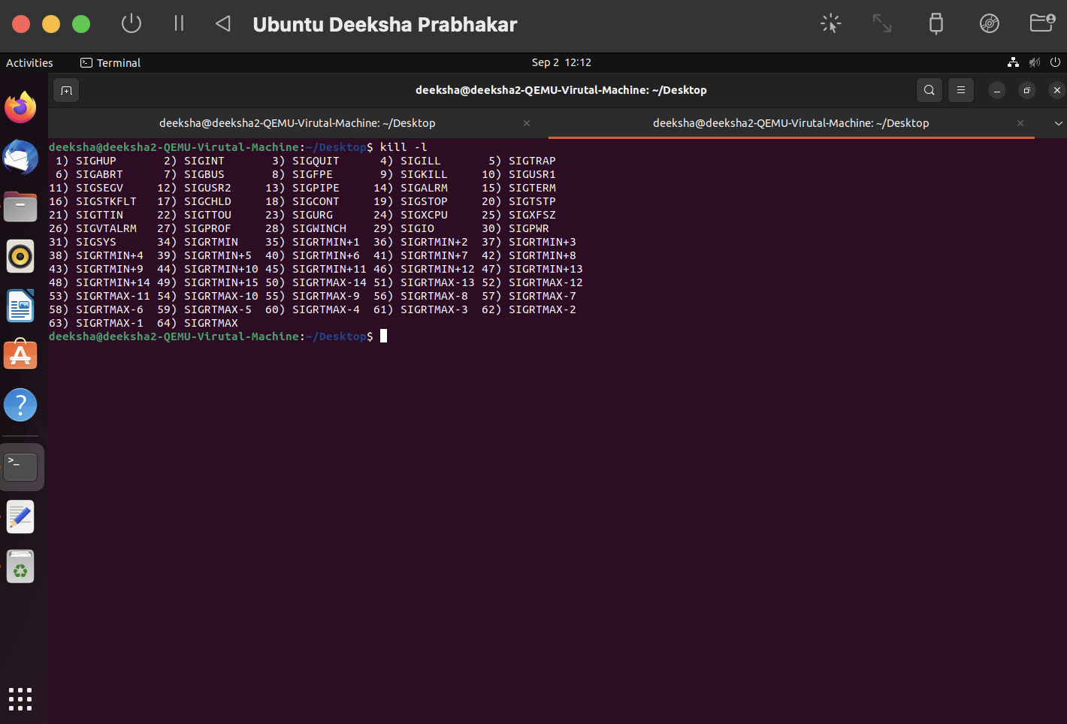

1. killall- It is used to kill all the running processes. If no signal name is specified it send an SIGTERM signal.

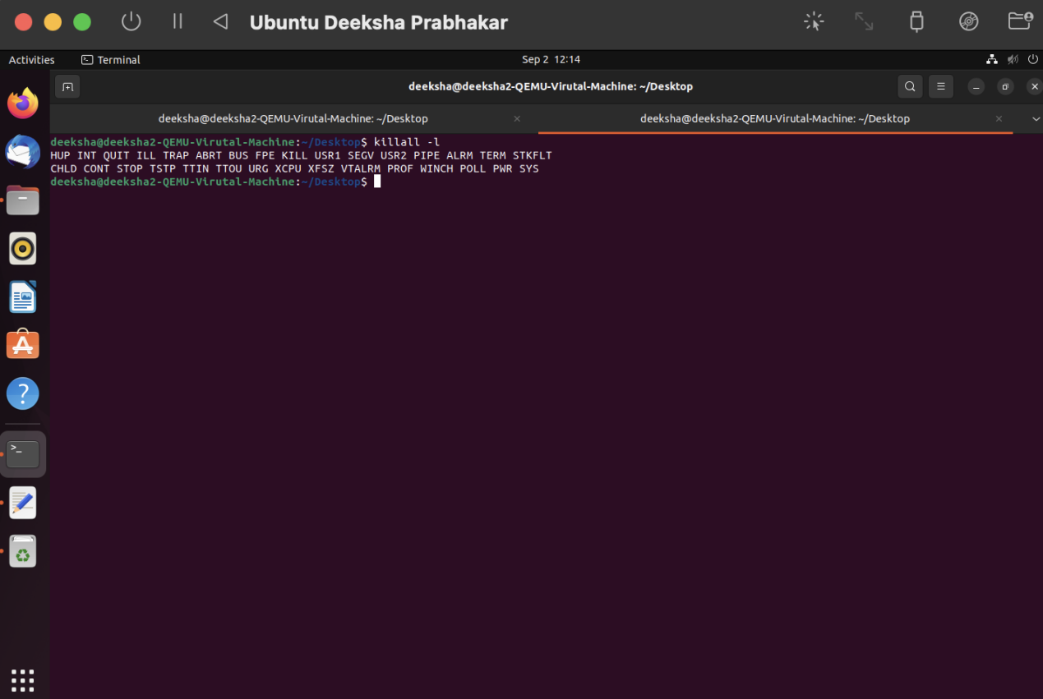

1. du- It is used to see disk storage.

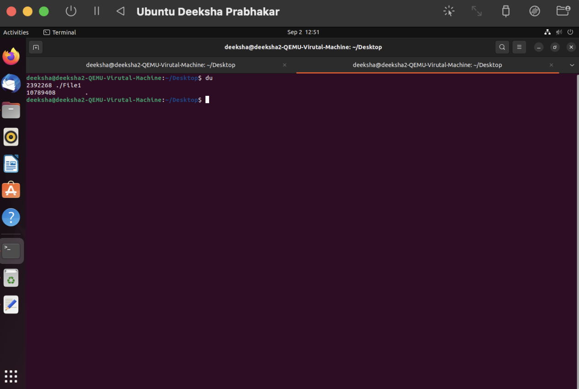

1. df- It is used to see the free storage available on the disk.

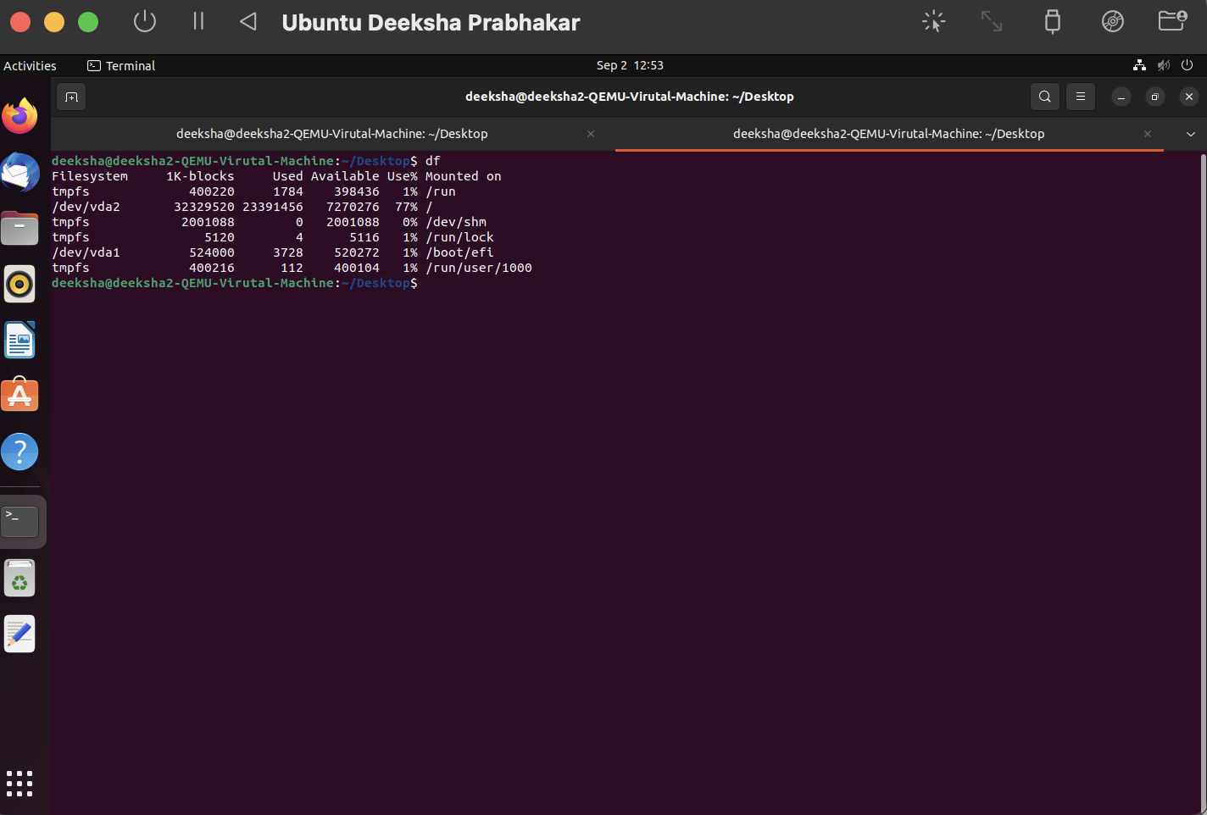

1. screen- It allows the user to have multiple screen sessions inside one terminal.

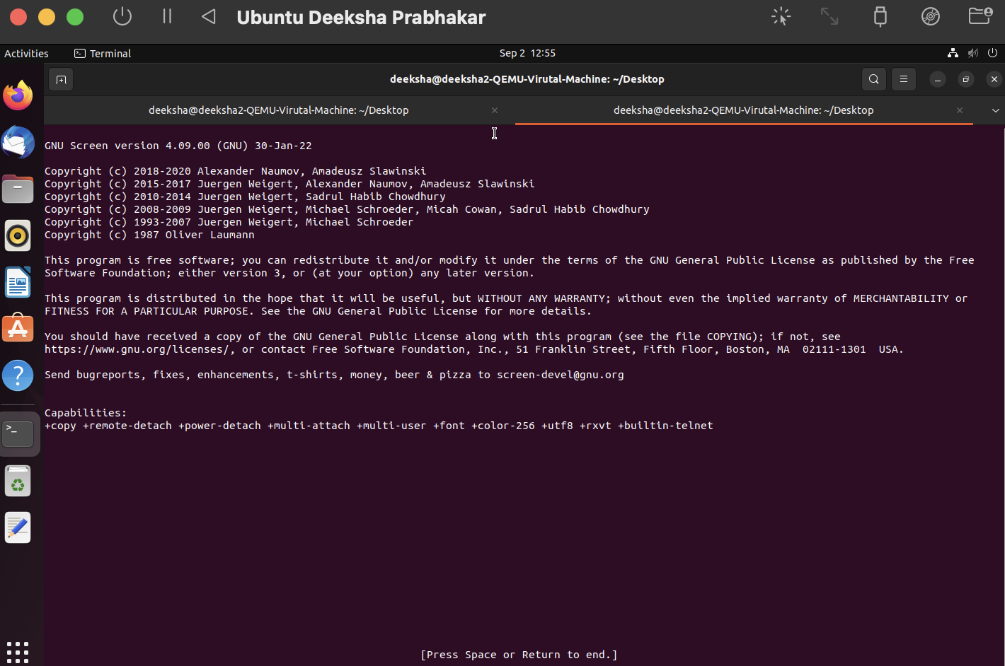

1. vim- It is used to open a text editor and edit a single file.

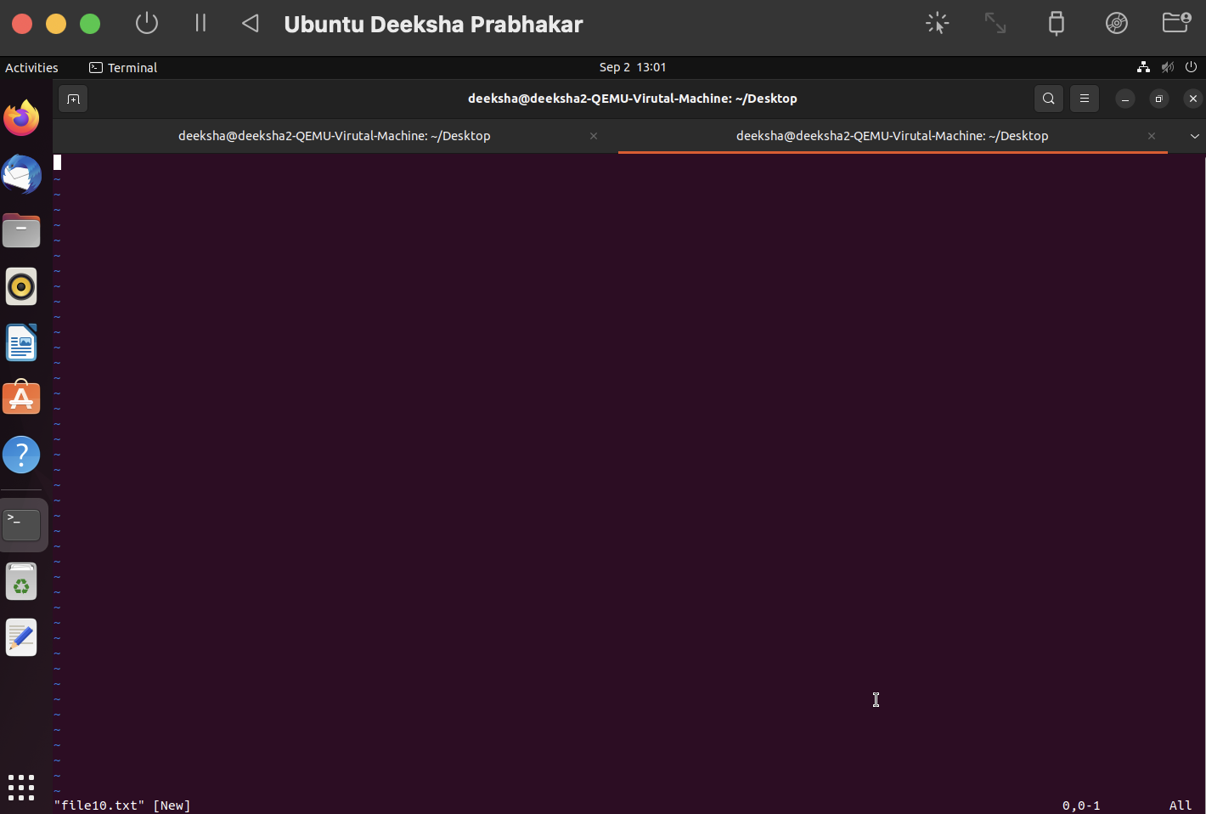

1. chmod- It is used to change modes and permissions for various files so that only users with permissions can access those files.

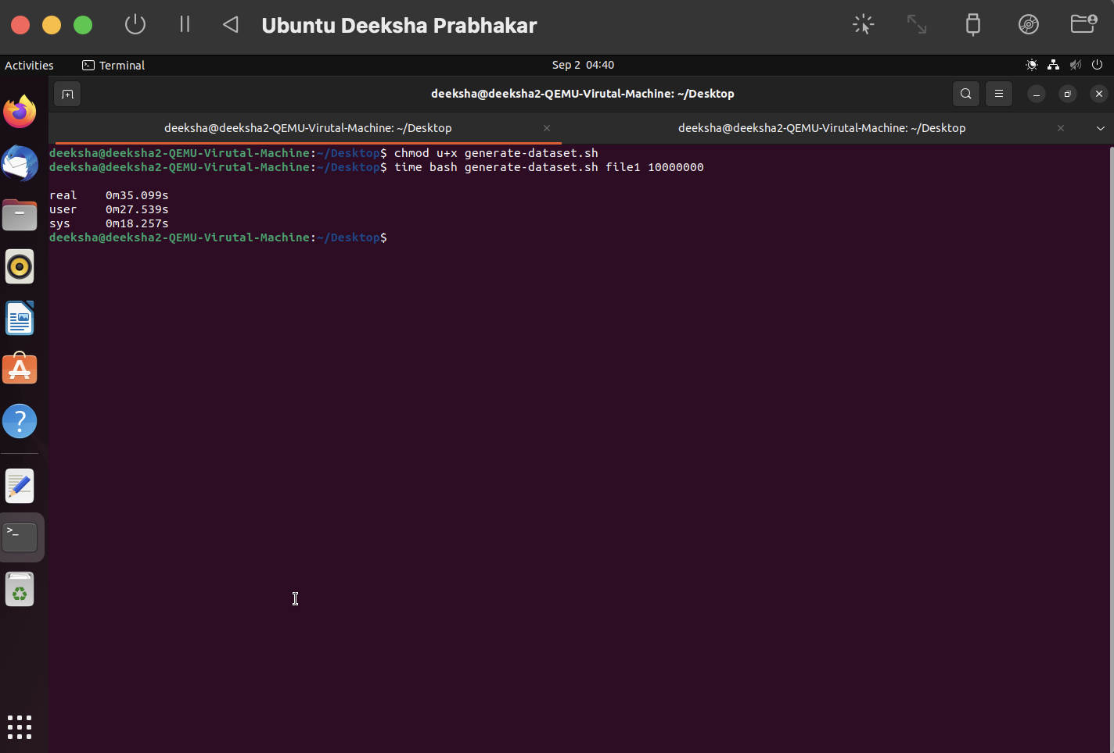

1. chown- It is used to change ownership of the files or directories.

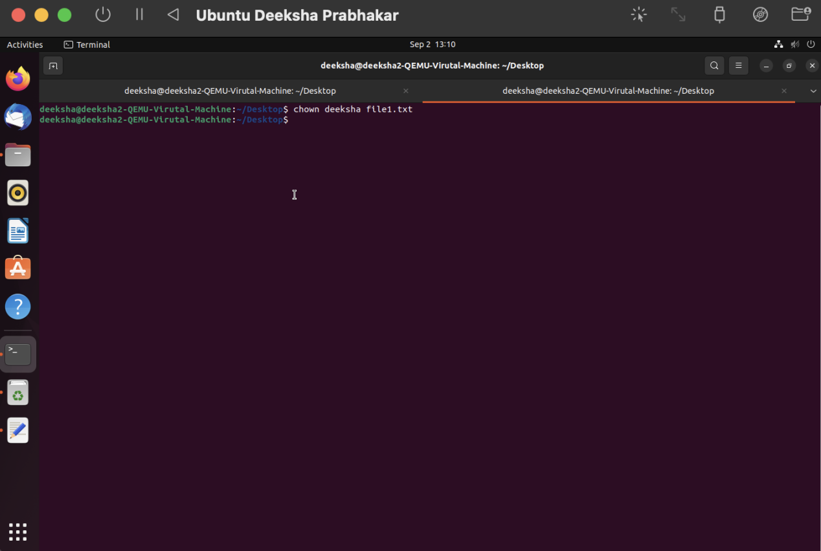

1. useradd- It is used to create or add a new user.

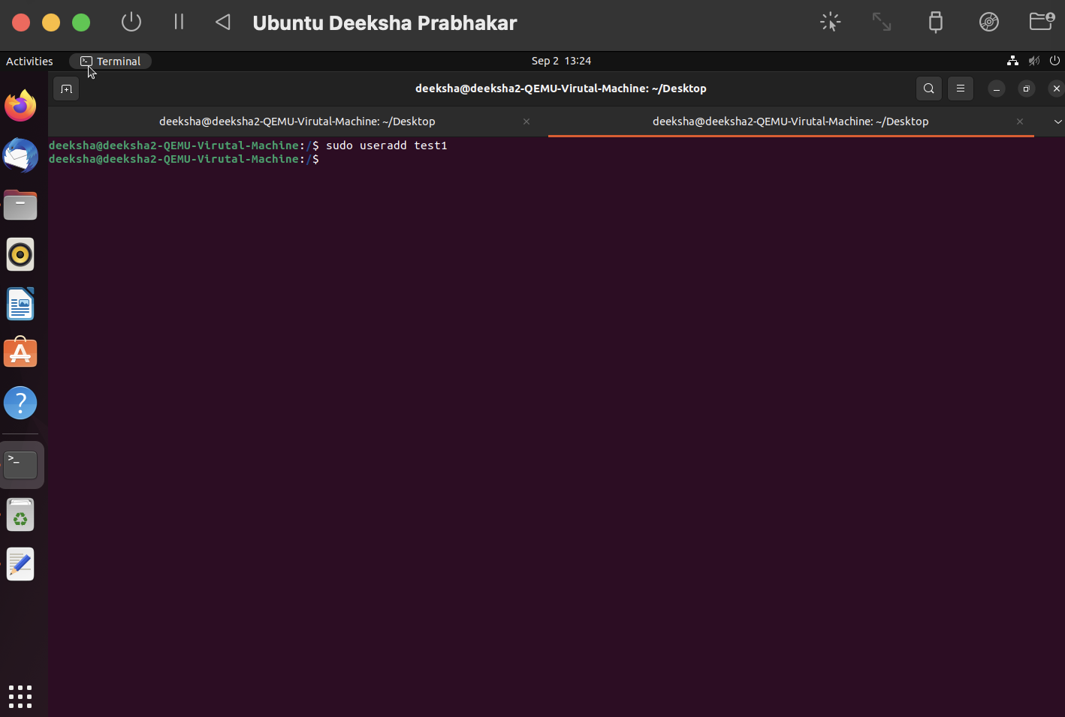

1. man- It is used to display the manual of the different commands.

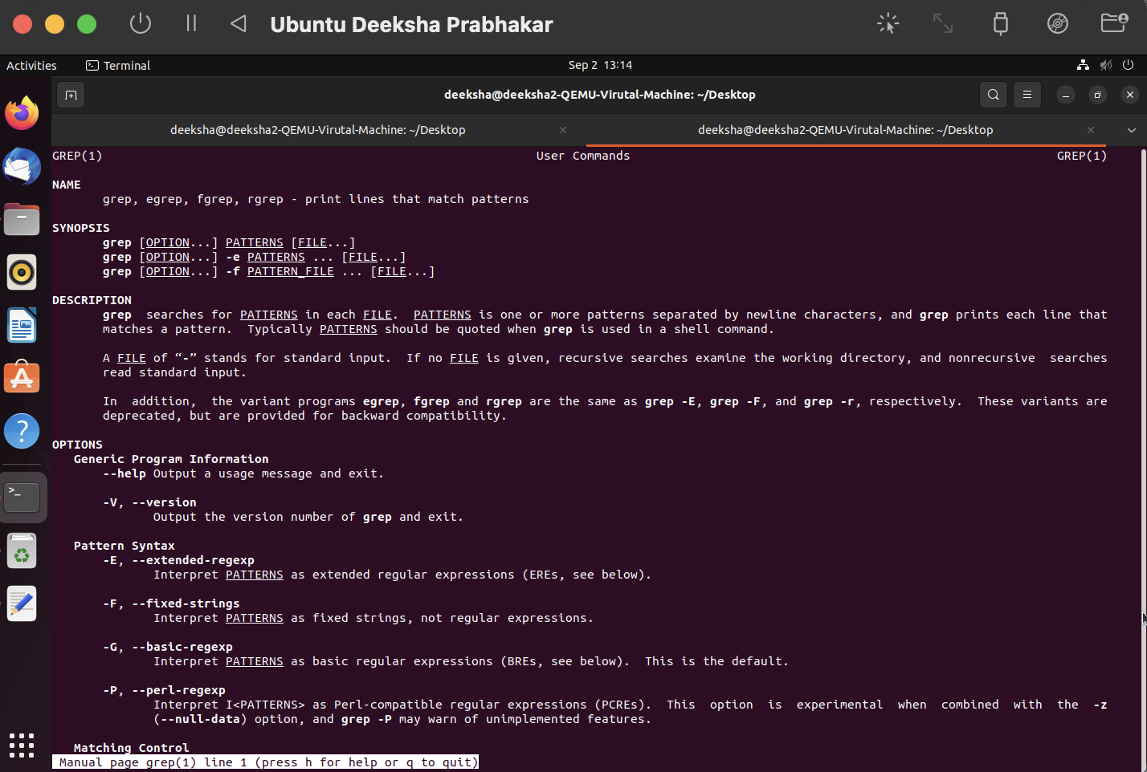

1. locate- Used to locate where the file with the input name is stored.

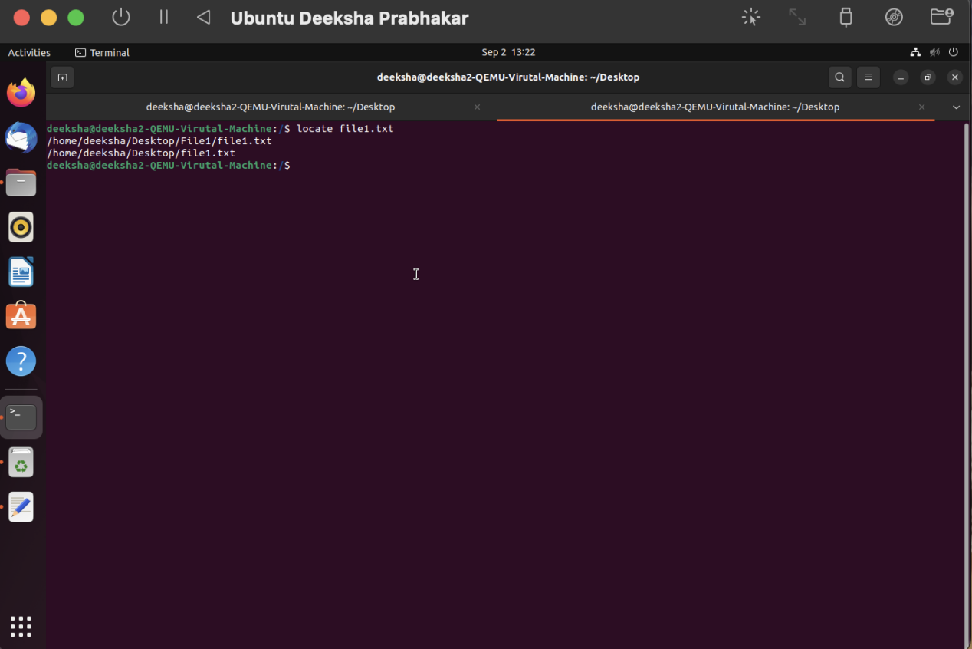

1. find- It is used to find the file which satisfies the specified conditions.

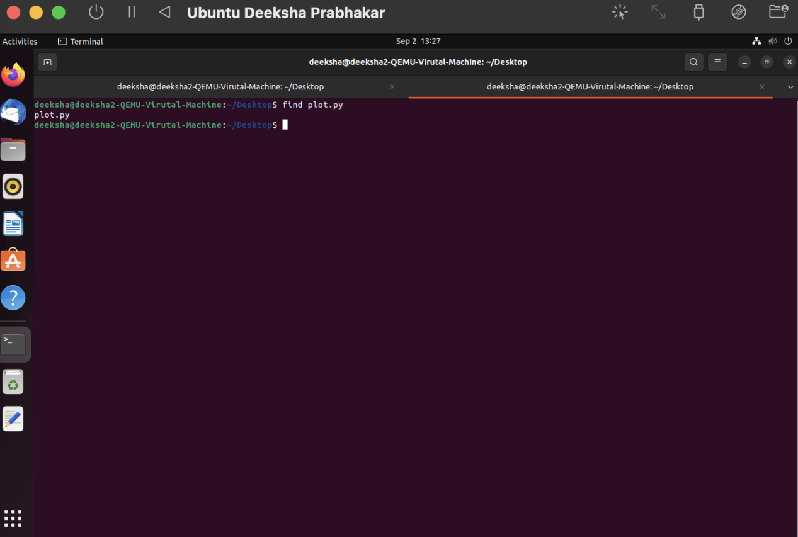

1. sed- It is used to parse through the file and manipulate text in the form of find, replace, insert or delete.

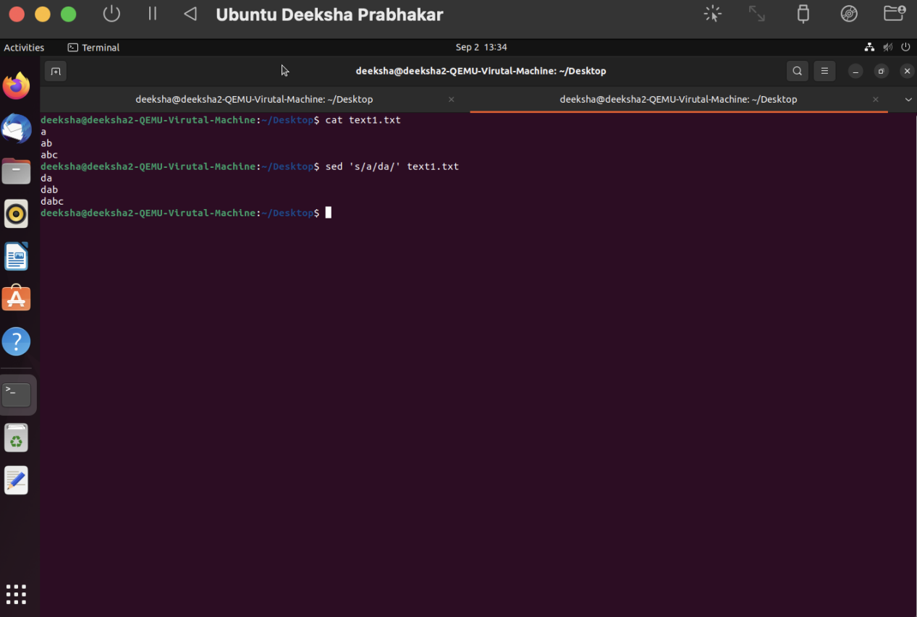

1. awk- It is used to manipulate the output of the print command.

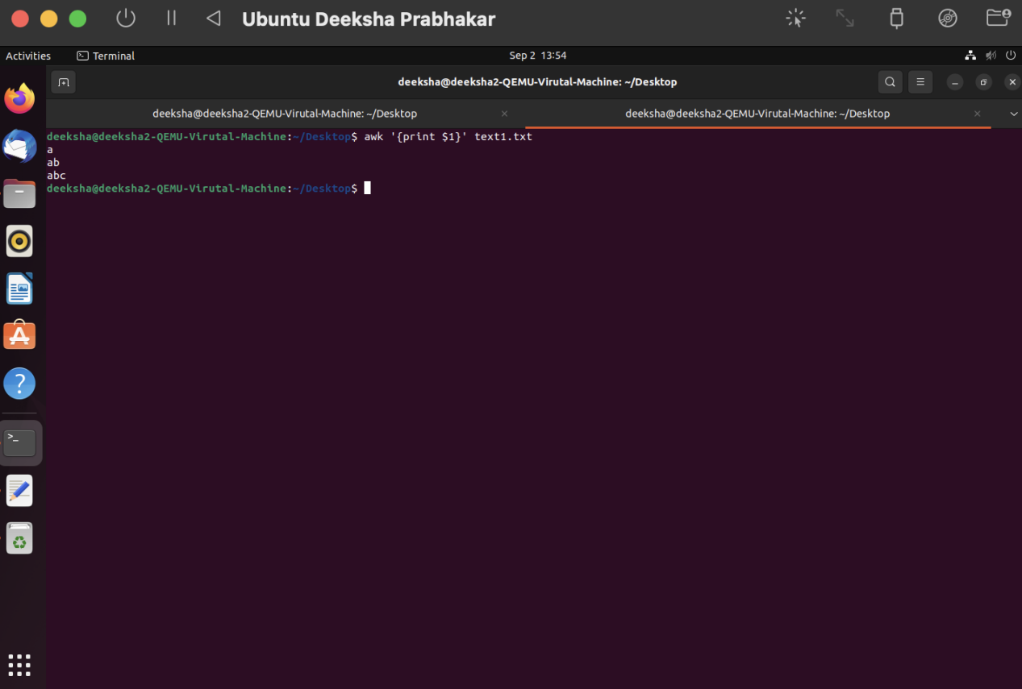

1. diff- It is used for a line by line comparison of two files.

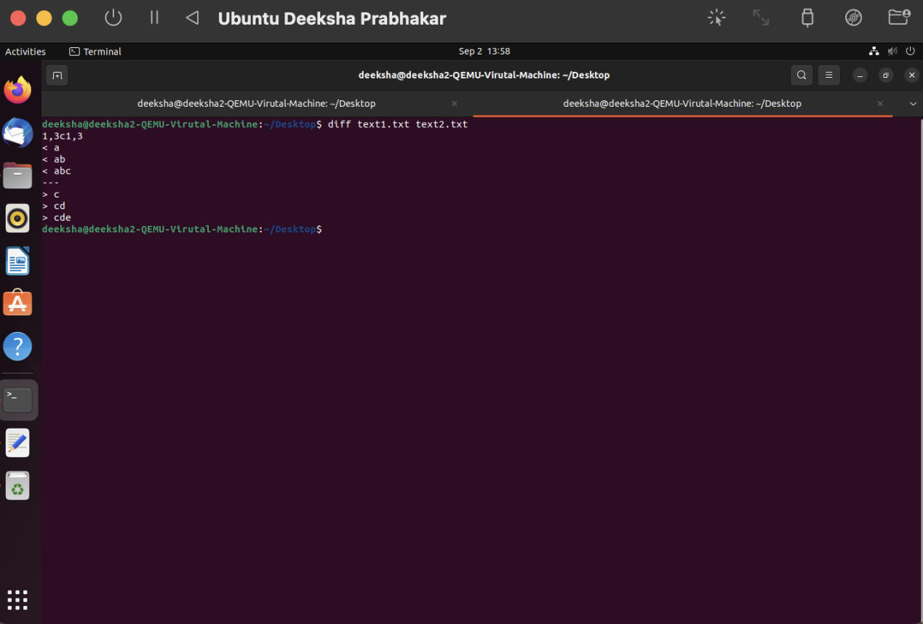

1. sort- It is used to sort the data stored in a file.

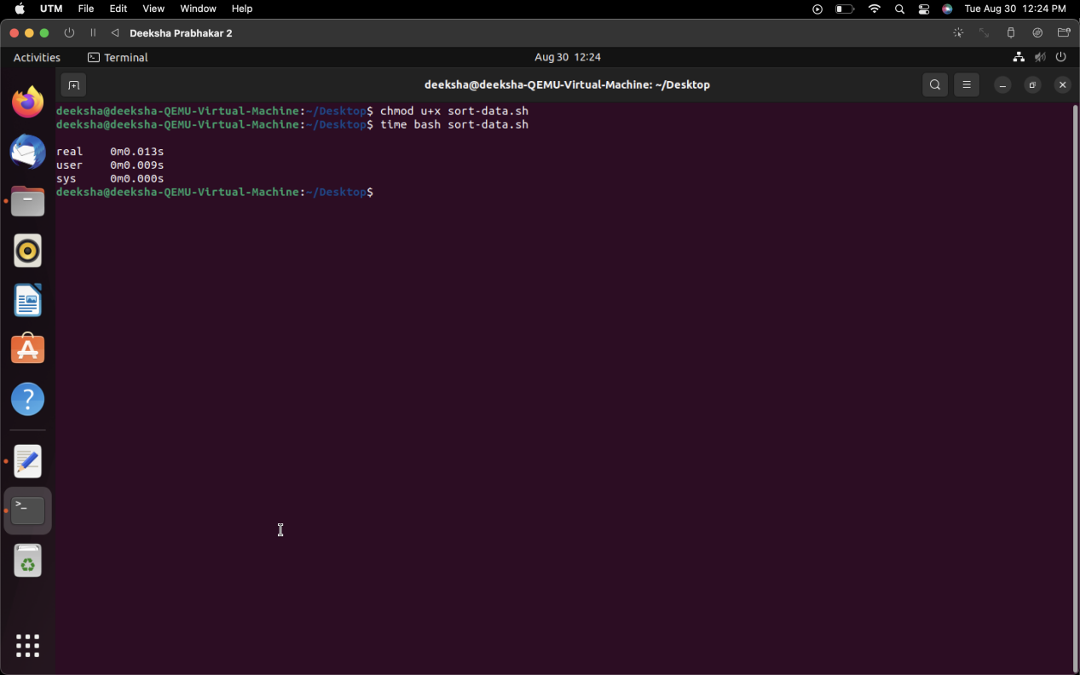

1. export- It is used to list the environment variables.

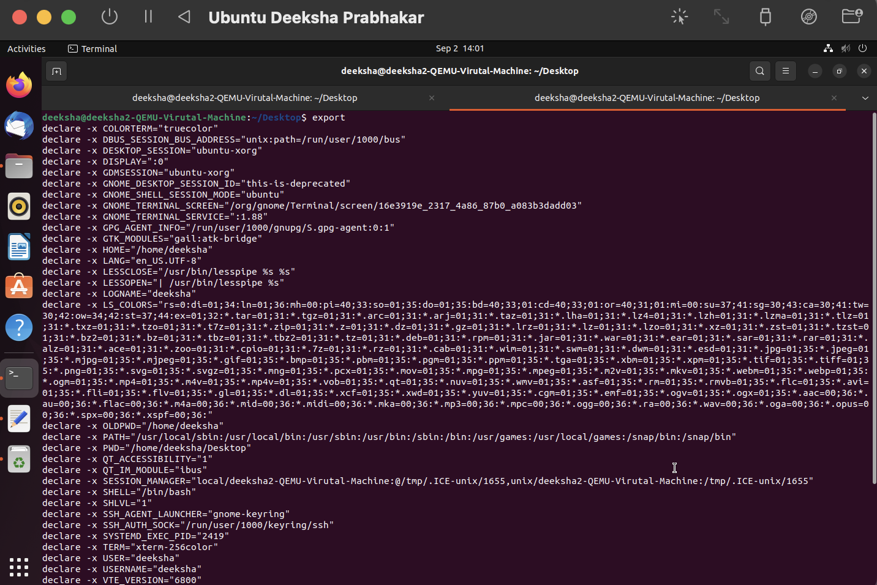

1. pwd- It prints the present working directory.

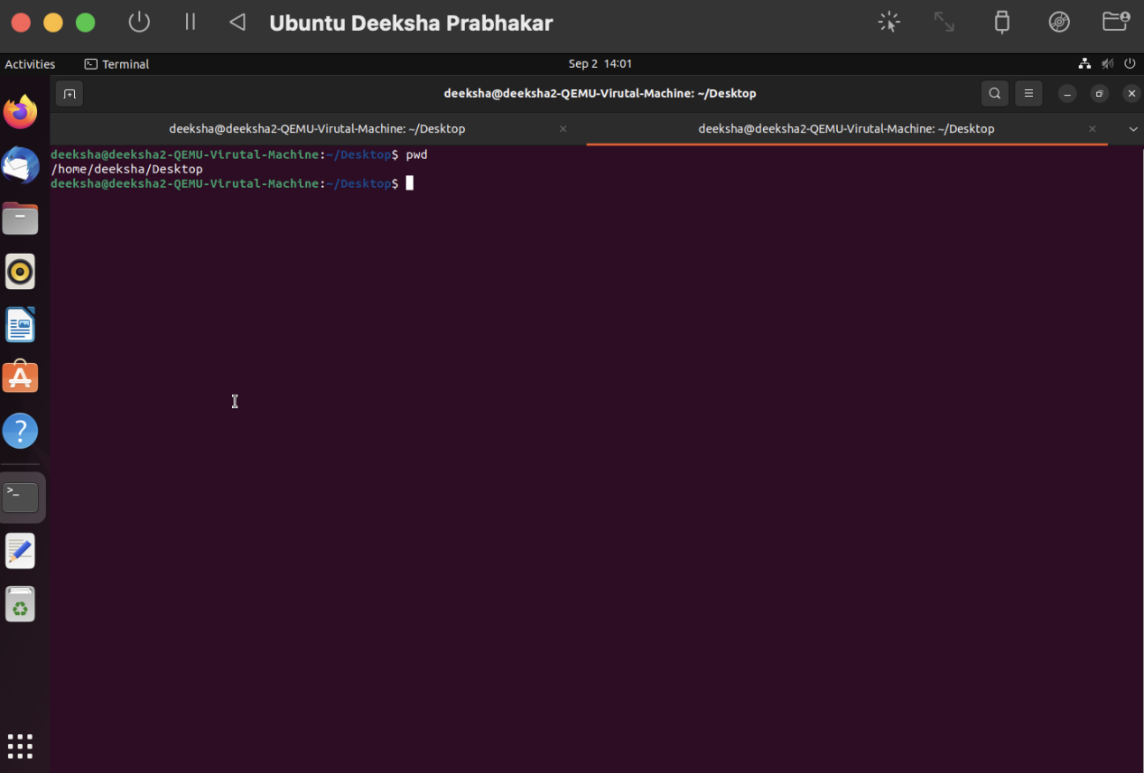

1. crontab- It is used to show and edit the jobs that are scheduled to run either at a specific time or periodically.

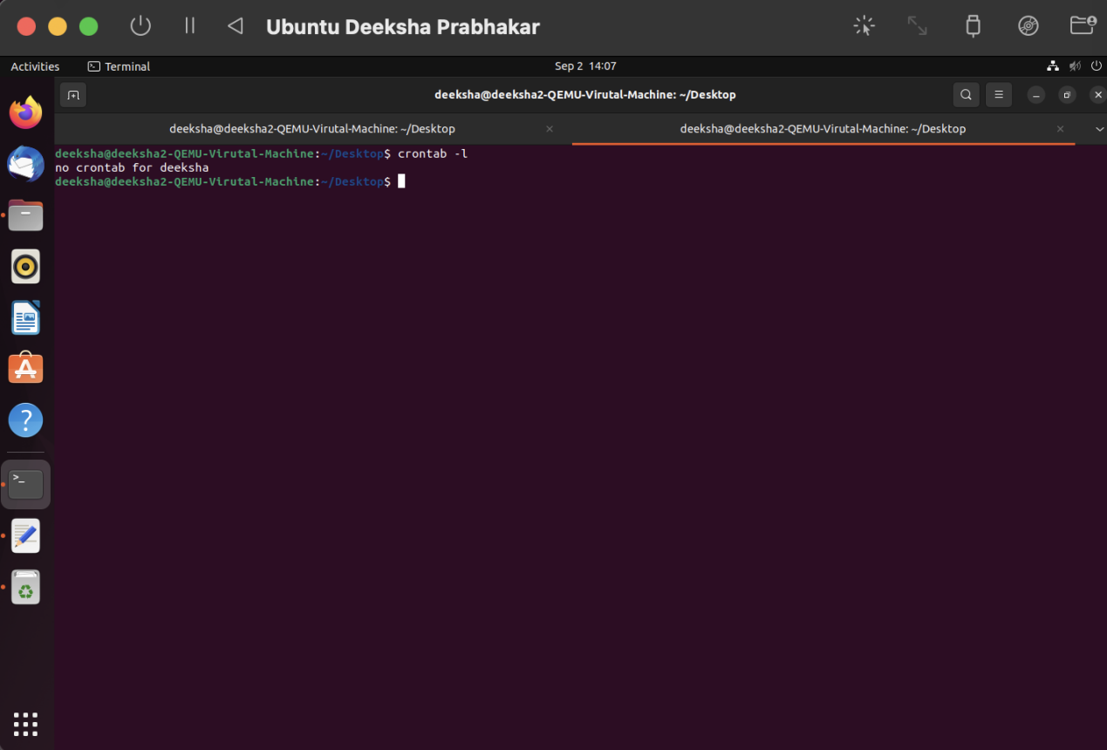

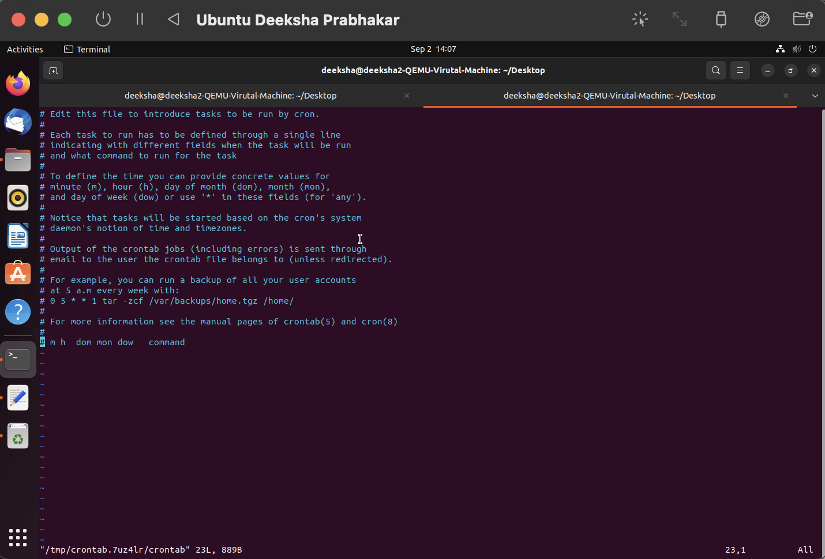

1. mount- It is used to mount certain removable devices and some file-systems or get information about them.

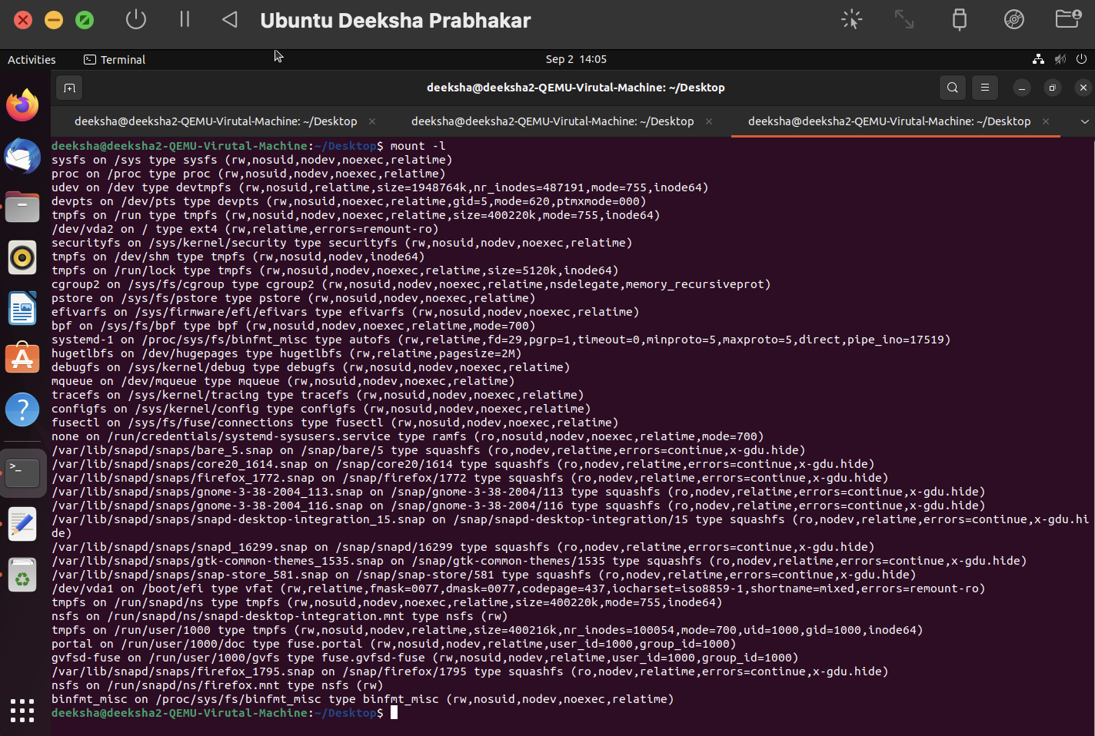

1. passwd- It is used to change the user account password.

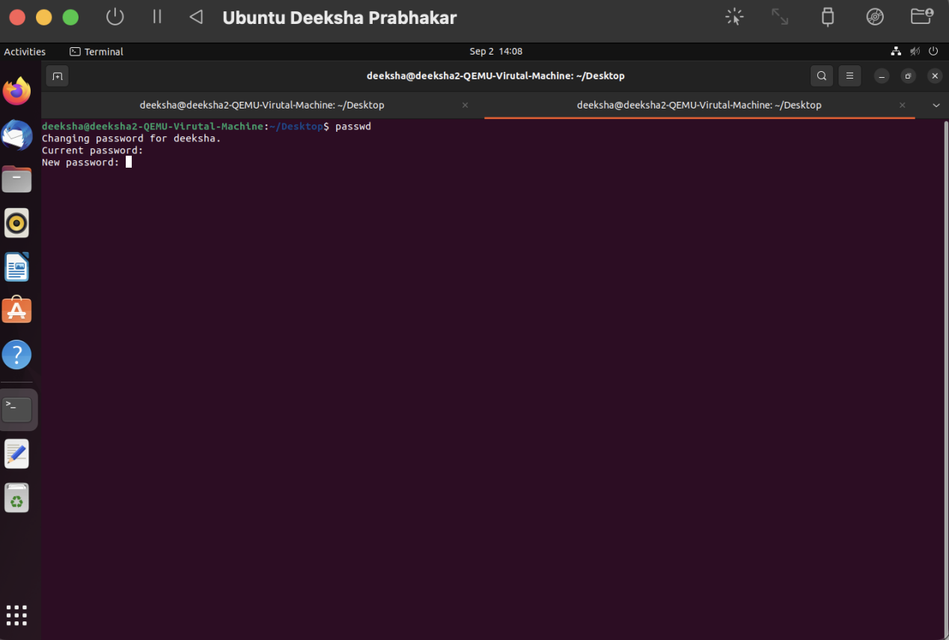

1. uname- It is used to show basic information about the machines hardware and software.

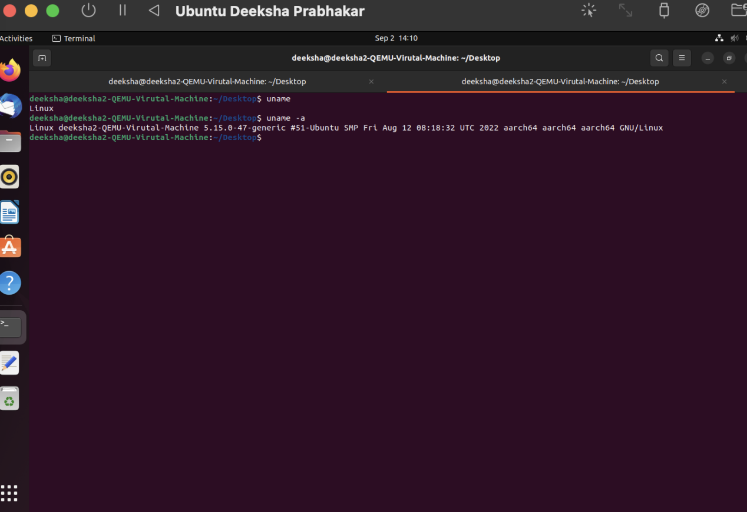

1. whereis- This is used to find the binary libraries, manual page files of the commands.

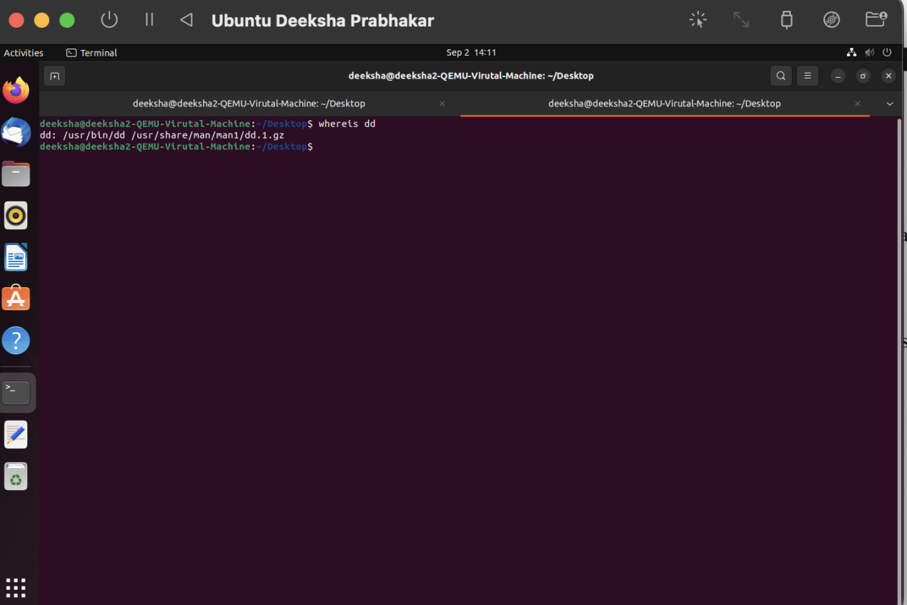

1. whatis- It prints a small description about the commands.

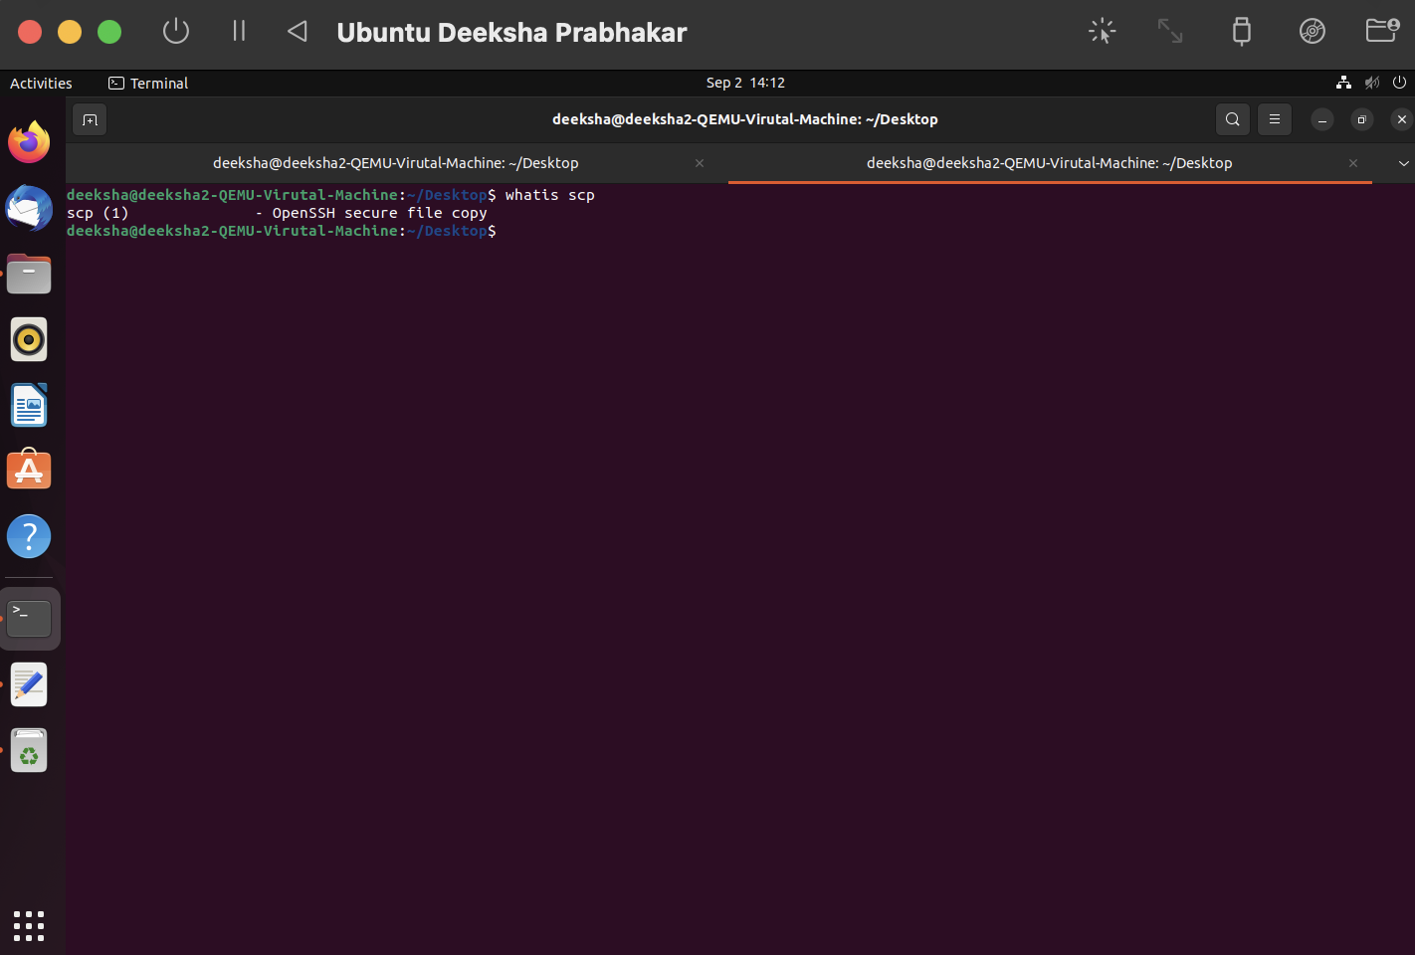

1. su- It allows the user to run or execute commands as a different user.

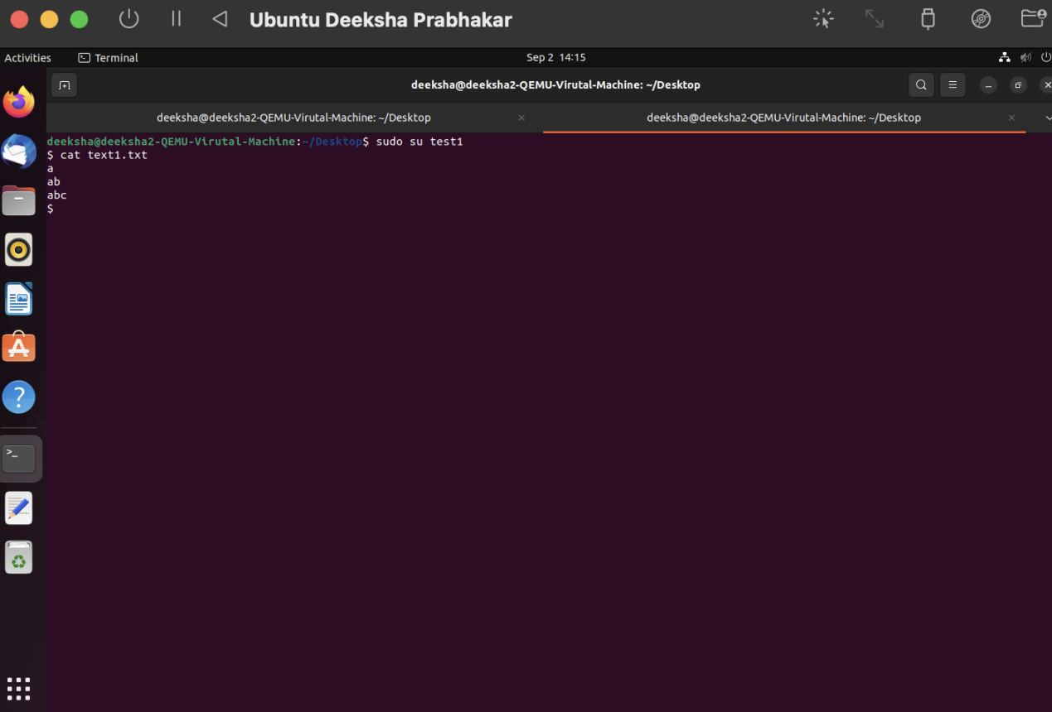

1. ping- It is used to troubleshoot and debug network connectivity issues. It shows if the other machine is responding to requests sent.

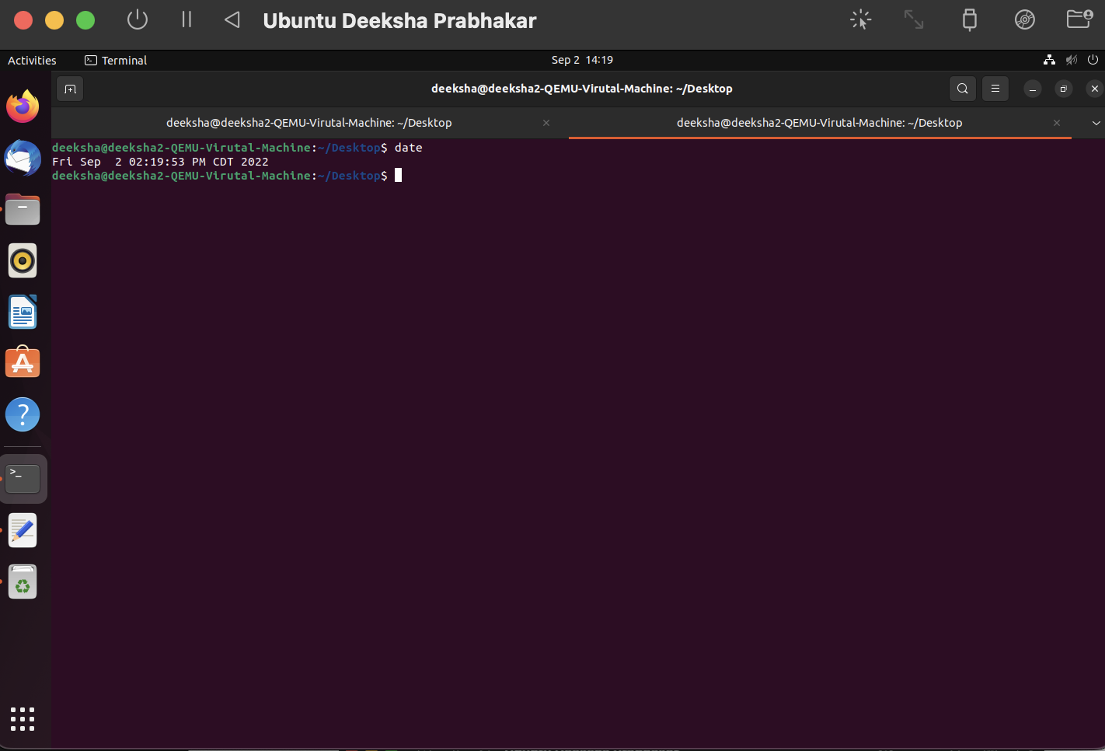

1. traceroute- It prints all points on the route the data packets take to reach the host machine from the server.

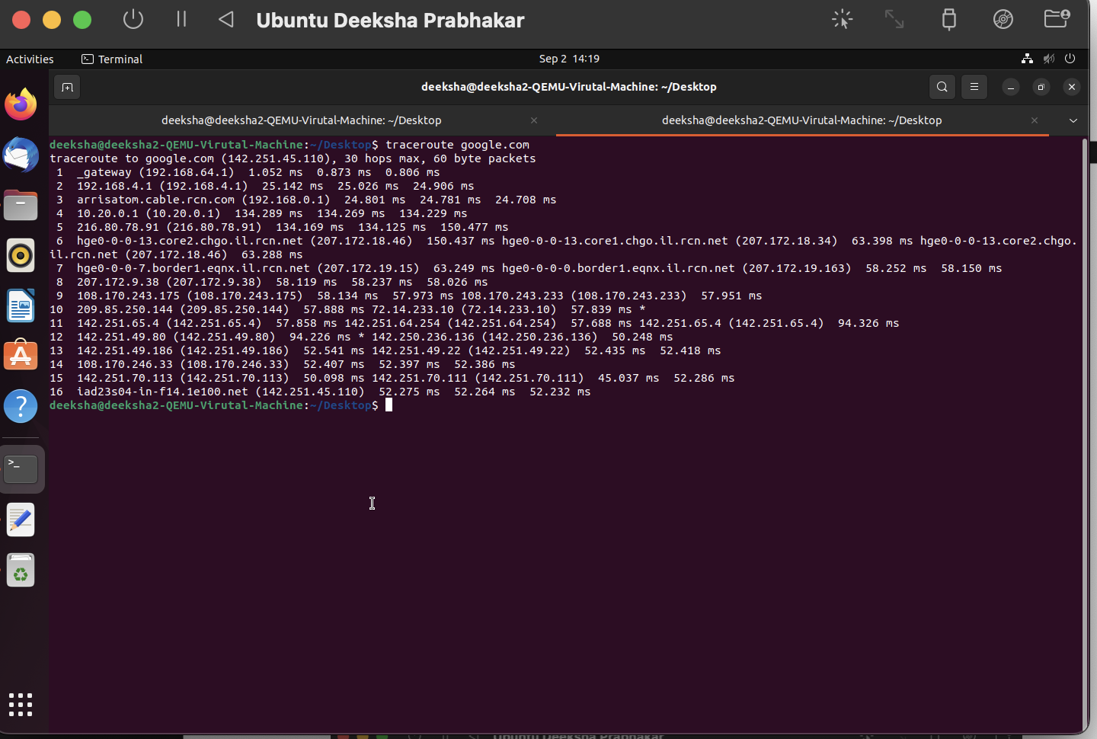

1. date- It is used to display the current date.



1. time- prints the time taken to execute a bash command or script.



1. wget- It is used to download files from the internet.

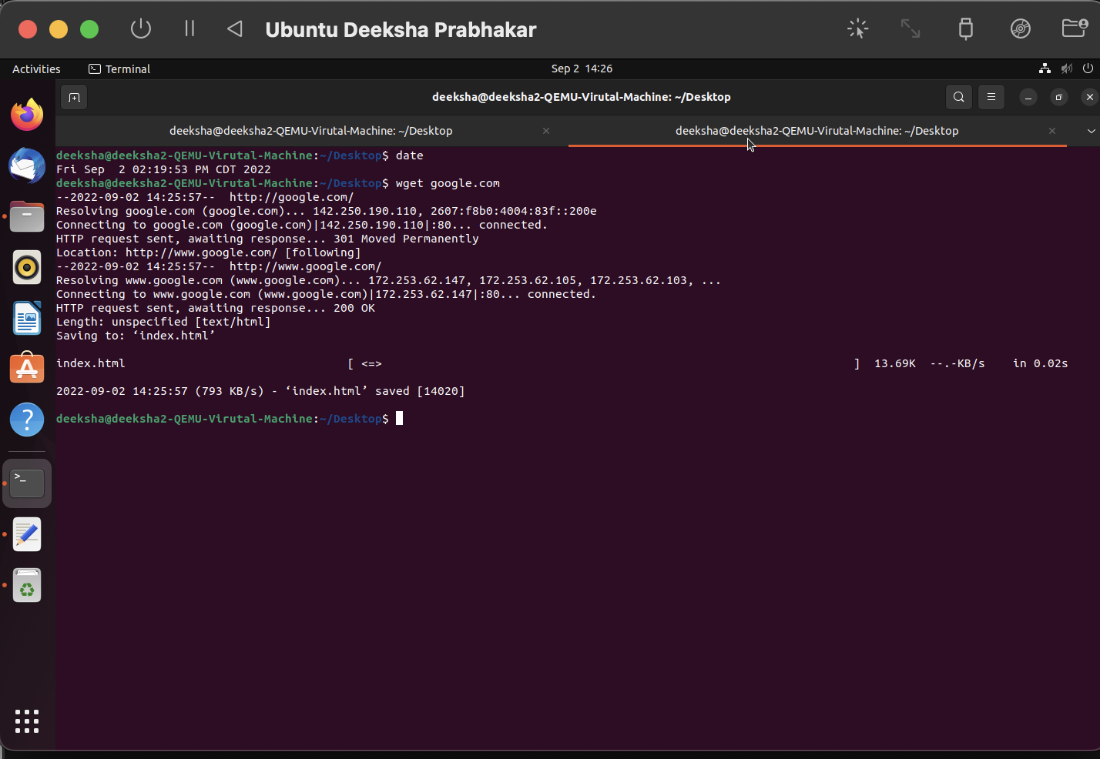

1. wc- It is used to print new line, get byte counts etc.

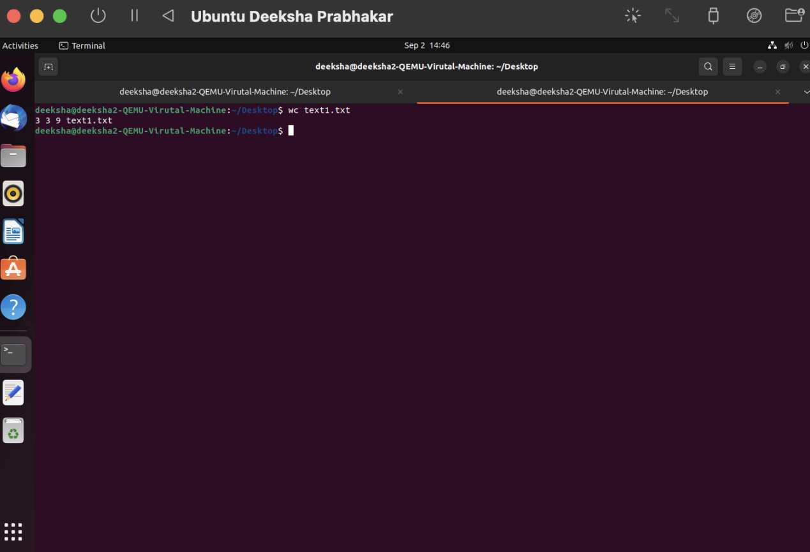

1. pwgen- It is used to generate a random password.

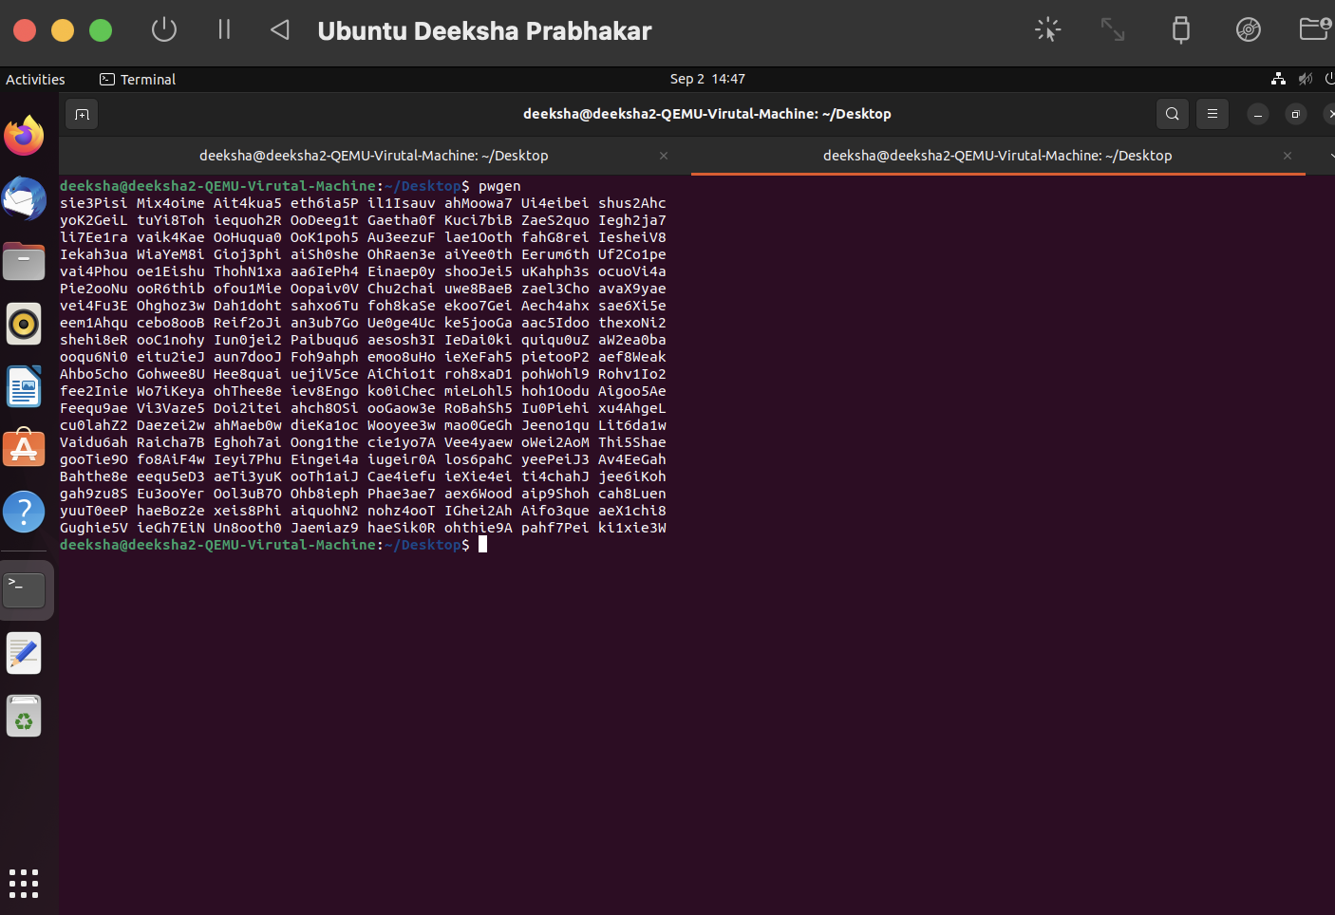

**A3.**

1.

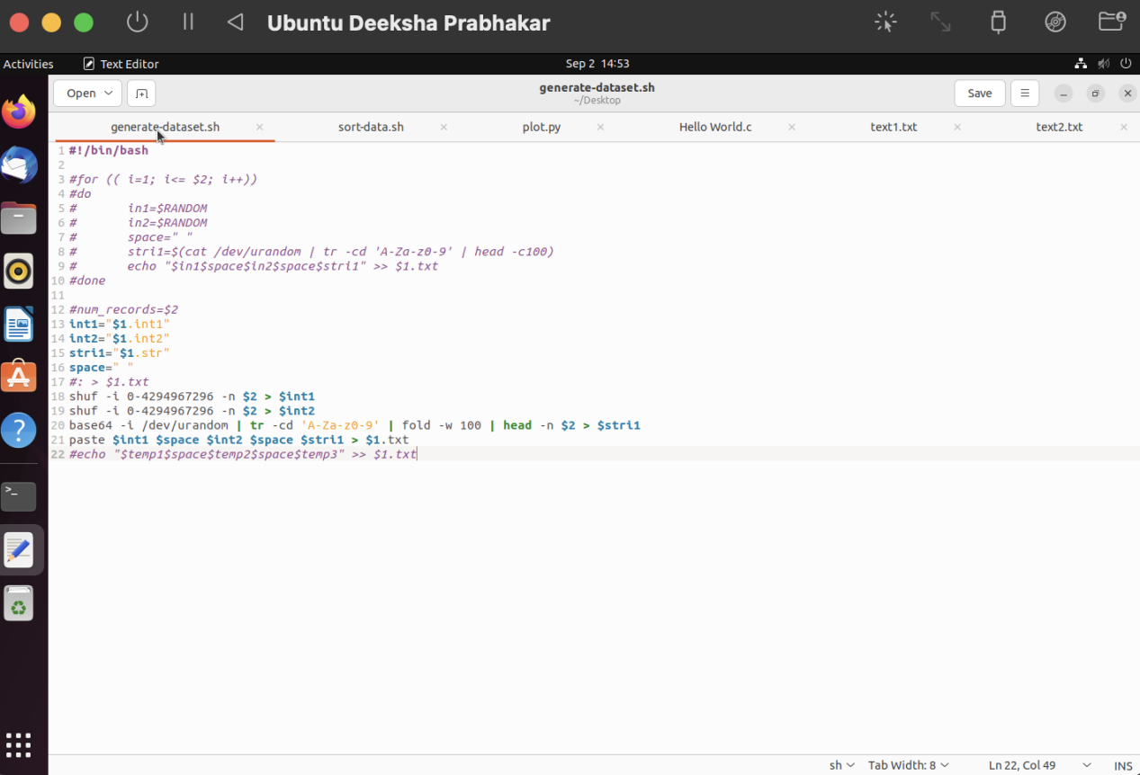



2.

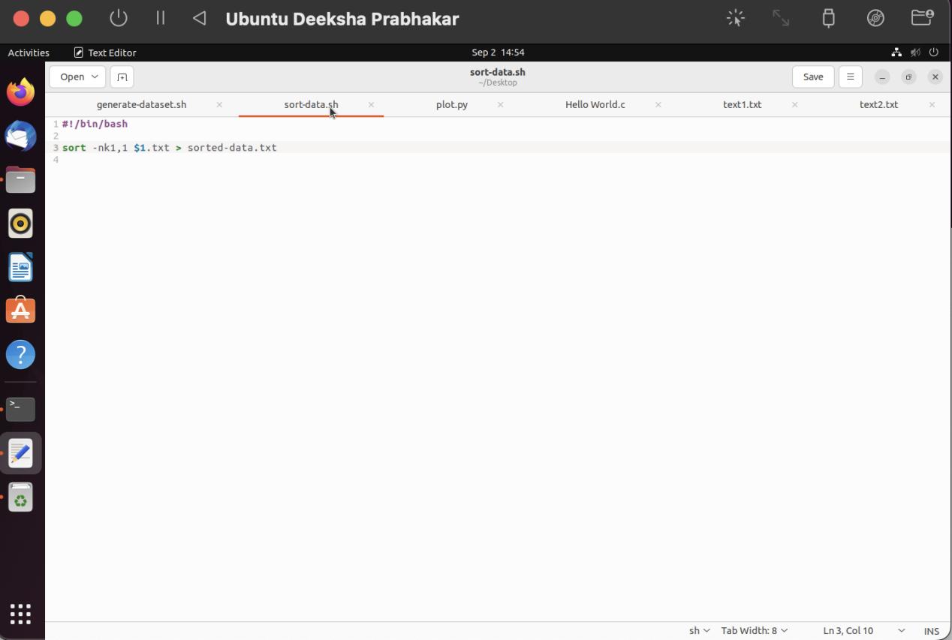



3.

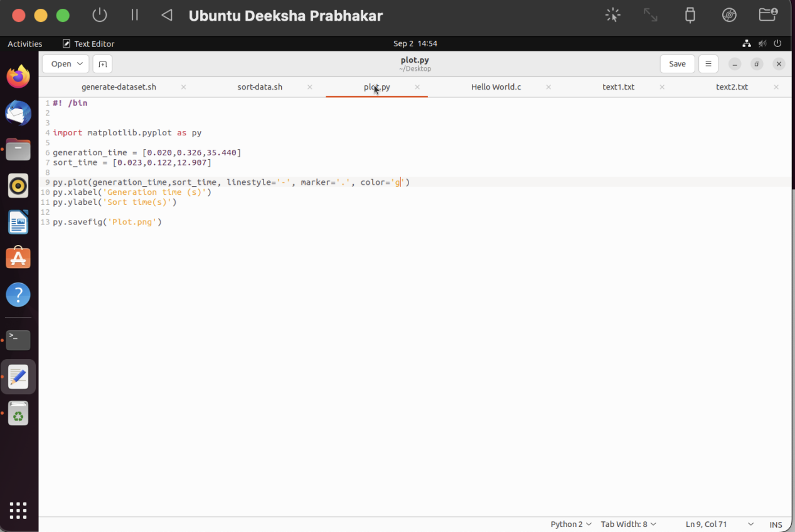

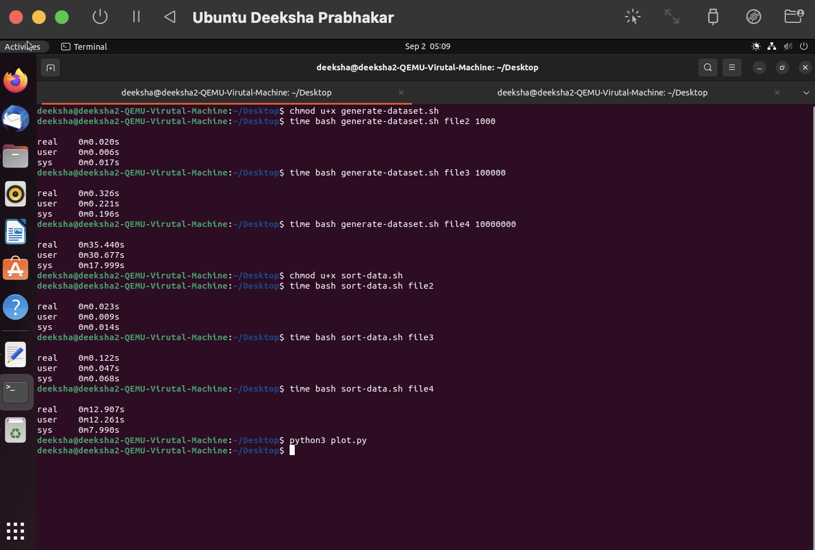

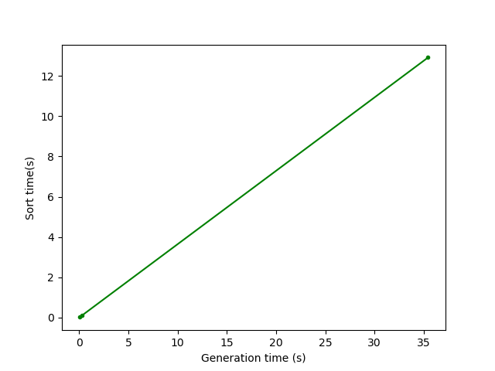

**A4.**

1. Changing the number of processors a VM has can greatly alter its performance. Increasing the number of processors for the VM basically means increasing the number of processors it has access to and can use at a given point of time.

We can assign minimum number of processors to the VM in situations where the host operating system is performing severe workload computations and the VM has to perform basic tasks or a single process.

We can assign maximum number of processors to the VM if the VM is performing a lot of parallel operations or data-intensive computations whereas the host OS does not need that much computing power.

It is a bad idea to assign maximum processors to the VM as the host operating system still needs to run a lot of background or supporting processes. This will cause the host OS to run slowly and in turn could lead to the computer itself crashing. Along with that, the more cores the VM has, the more overhead they will cause due to context switching.

1. The different paravirtualization options are:
   1. **None:** It straight away turns off exposure to paravirtualization interface.
   2. **Legacy:** This option is for machines that have been created with older versions of VirtualBox and they will choose a paravirtualization interface to ensure smooth running of the VM.
   3. **Minimal:** It just announces the existence of a virtual environment. This is mandatory for any Mac OS X guests.
   4. **Hyper-V**: It uses a Microsoft Hyper-V hypervisor interface. It basically allows one VM to run on top of another VM. It is recommended for Windows guests.
   5. **KVM:** It provides a Linux KVM hypervisor module that gives the Linux kernel native virtualization capabilities. This is recommended for Linux guests.

KVM would be best to use with Ubuntu (or Linux) because it does not require modifying the guests OS.

1. Different types of Storage Controllers:
   1. **IDE:** IDE storage controllers expose the IDE disks to Virtual machines. It is based on IBM PC Industry Standard Architecture 16-bit bus standard. It is the only one available for Legacy OSes (as they don’t support other storage controllers).
   2. **SATA:** It is a serial ATA controller. It is a modern controller that can support a higher number of devices. It runs faster than IDE. It is useful in cases where you have to connect upto 30 storage devices to the VM.
   3. **NVMe:** Thisinterface is built specially for non-volatile storage media like SSDs. It is faster than SATA controllers and can be used in cases where low response time is required. It can be used in scenarios where you want to connect upto 255 storage devices to the VM.
2. Different types of Network Adapters are:
   1. **NAT (Network Address Translation):** It masks all network activity from the VM under the Host OS and thus the VM can access most of the client applications over any network connection that the host has. It is good for browsing the web and downloading files.
   2. **Bridged Adapter:** Connects to one of the local cards and exchanges network packets directly without going through the host network. It is useful for running servers.
   3. **Internal Network:** It can directly communicate with any other VM present on the same host that is connected to the same internal network. It is used for testing firewalls.
   4. **Host only network:** It is a combination of internal and bridged where the VMs are connected to each other and the host. It is used for testing client/server softwares.
   5. **USB 1.1:** It is supported for all virtual machine hardware options. It’s maximum bandwidth is 12 Mbps.
   6. **USB 2.0:** It is supported only by compatible VM Hardware versions. It’s bandwidth is 480 Mbps.
   7. **USB 3.0:** It is supported by Linux guests with Kernel version 2.6.35 or later and for Windows 8 guests. It’s maximum bandwidth is 4.8 Gbps.